Warm up 12/15-12/19

The table below lists the applications containing rare metals for which recycling is particularly strategic
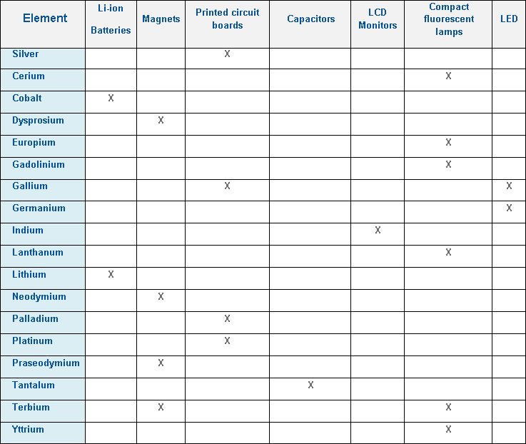

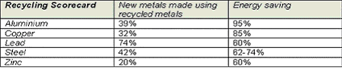
EU figures indicate that using recycled raw materials, including metals, cuts CO2 emissions by some 200 million tonnes CO2 emission reduction every year.
(Source: British Metal Recycling Association)

