Name
Date

Physics Graphs and Diagrams- Energy
Show all of your work off to the right side of the diagrams.
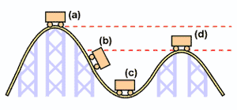
1a) If there is 50,000 J of mechanical energy at any time in this roller coaster, label each cart with a magnitude of PEg and KE.
1b) Draw a bar graph for EACH of the four rollercoaster cart positions. Include Mechanical energy, Potential Energy, and Kinetic Energy in each BAR graph.
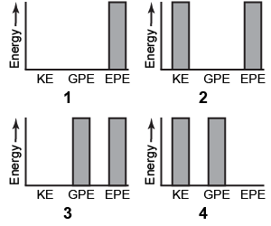
2) Calculate the momentum of the two after grandma runs into her grandchild.
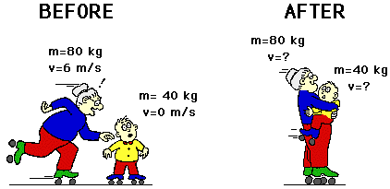

3) Calculate the velocity of the 1000kg car. (Hint- be careful about directions!)
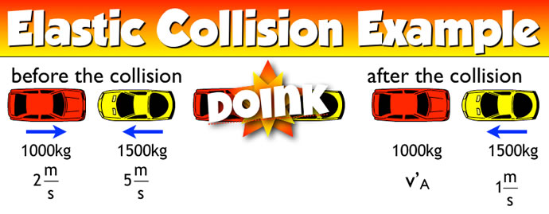

4) Calculate the PE elastic. (Hint- you must find k via the formula for Newton’s 2nd law.)
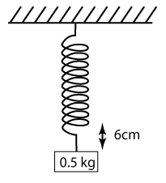
5 Calculate the work for each diagram. Use W= F(d) cos 0 for ALL of the diagrams.
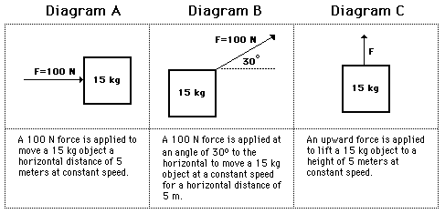

6 Calculate the power needed to make it up the steps in horsepower. Hint- at the end you need to convert J/s to hp.
(1 hp= 740 J/s, aka J/s is 1 watt)

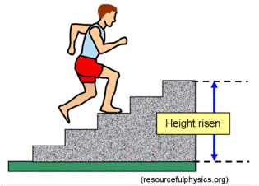
Extra Credit- What is the runner’s PEg when he reaches the top of the staircase?
Extra Credit- What is the runner’s KE while running up the stairs?

