Notes – Periodic Table #1
Boxes 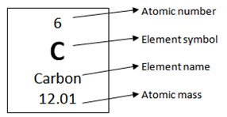
Each box represents an ____________________
Boxes ________________ by _______ atomic number from left to right
Atomic number = #P____________________ = #Electrons (APE)
Each _______________ has a ________________________ number of ______________________
and therefore, a _________________________ ATOMIC number
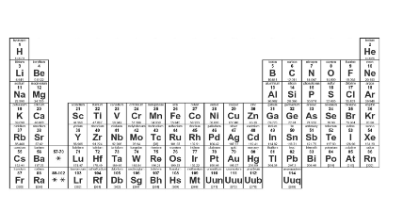
Rows = Periods
(number the periods 1-7)

Rows are called ______________________

Periods represent _________________________
used by an atom’s electrons

Atoms in the ___________ ______________ all have electrons in the ___________ __________ __________
*The period # tells us how many _________________________ an atom has.

Columns = Groups/Families
(number the groups/families 1-18)

Columns are called ___________________

Or _______________________________

Atoms in the _____________ __________________ or ________________ have similar ________________ and __________________________ properties.

*The group # tells us how many ________________ ________________ an atom has.

VALENCE ELECTRONS (VE)
Elements in the same column have similar properties:

They have the _____________________ of _________________ in the ____________ energy level

Electrons in last energy level are called ________________________________ Electrons

______________________ _____________________ - cause all the ____________________ changes!

Valence Electrons Continued:
For Groups ______ through______, ignore the “1” (or tenth’s place) when deciding how many valence electrons an atom has.
Rules:
Group 1 = ____ valence electron
Group 2 = ____ valence electrons
Group 13= ____ valence electrons
Group 14= ____ valence electrons
Group 15= ____ valence electrons
Group 16= ____ valence electrons
Group 17= ____ valence electrons
Group 18= ____ valence electrons
**special case for He= only 2 valence electrons even though in Group 18

Octet Rule (8)- the maximum number of __________ _____________ allowed in an energy level.

____________ is a special case in which it only needs _____ valence ___________ to be full.

Practice-
What element is in Group 2, Period 2?
What element is in Group 16, Period 3?
How many valence electrons are in Group 14?
How many valence electrons are in Group 2?
How many valence electrons are in Group 18 (except He)?

