Warm up Dec 1st -5th

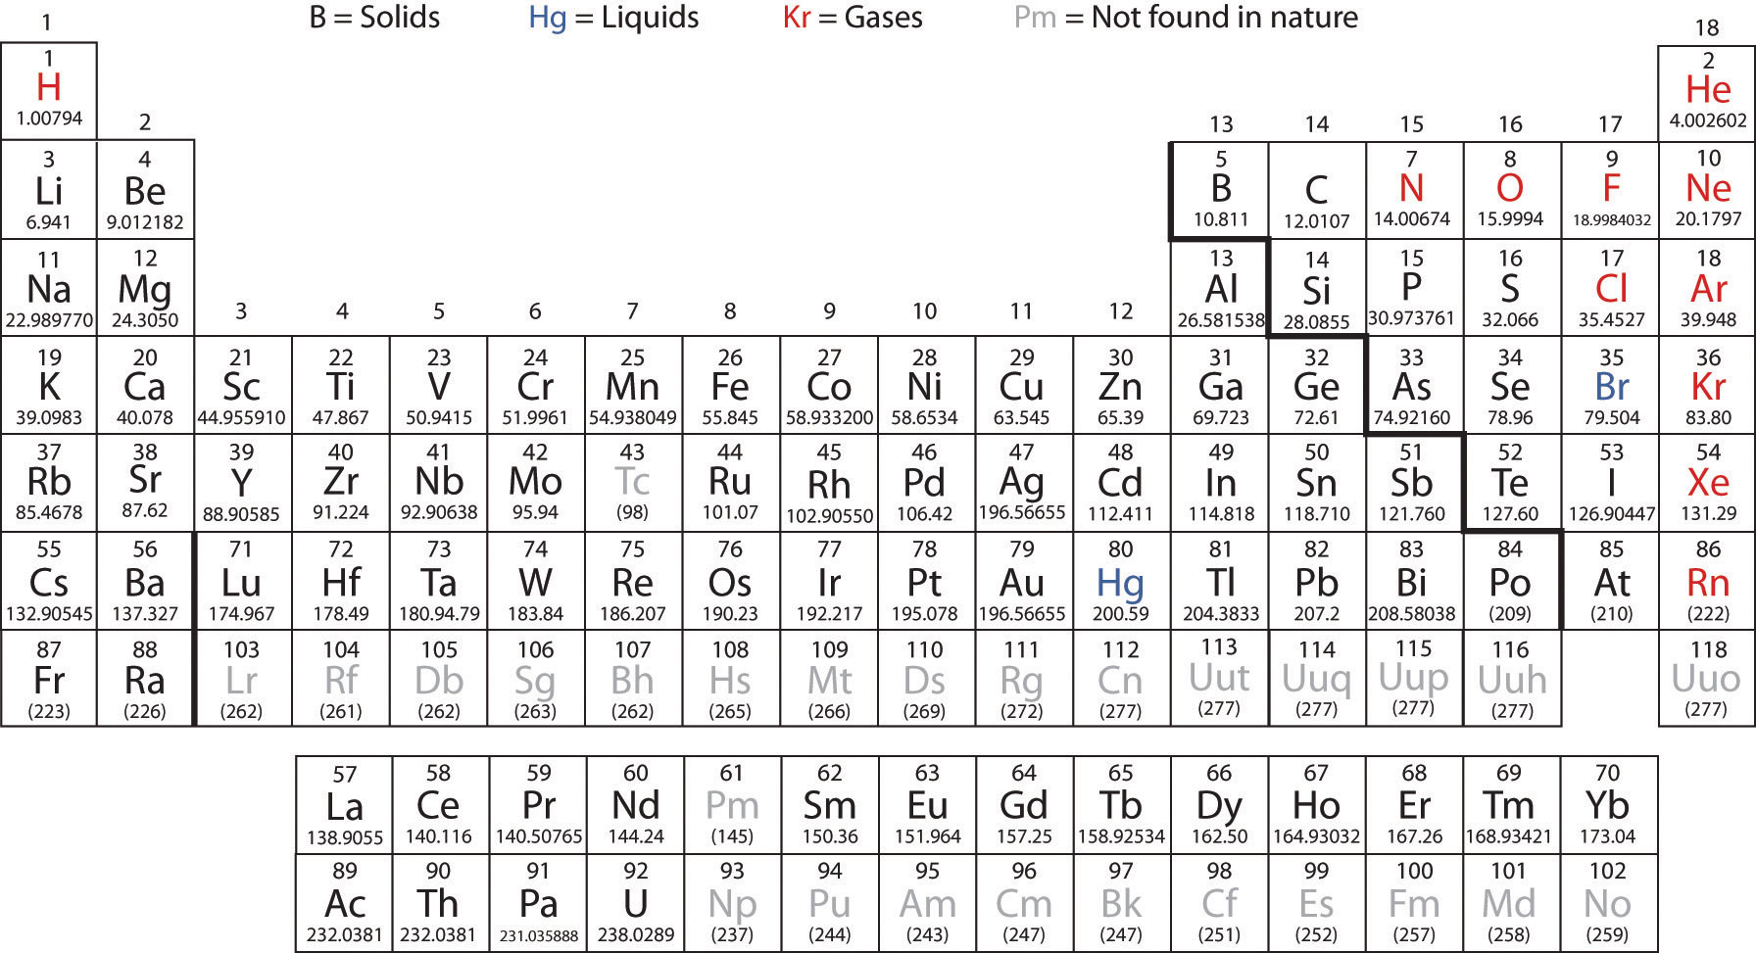

Ahhh rain …Good Morning! 12/03/14

Bell Ringer- What is the Group # and
Period # for Mg?

M- What element is in Group 2, Period 4?
T- What is reading a periodic table like?
W- What is the Group # and Period # that Ca is located at?
R- What is the family name for Group #18?
F- How many valence electrons does anyone in G 17 have?

