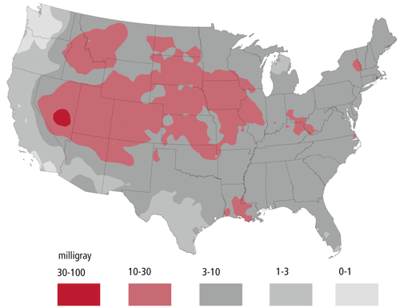
Total external and internal radiation dose (mGy) to the thyroid of adults in the United States from all tests at the Nevada test site. Source: National Cancer Institute

From Preparatory Commission for the Comprehensive Nuclear Test Ban Treaty Organization
http://www.ctbto.org/specials/testing-times/27-january-1951-the-first-nuclear-test-at-the-nevada-test-site/

Video clip- Nevada test site (1st underground explosion) (History Channel) (middle of video…very short)
http://www.history.com/this-day-in-history/nevada-is-site-of-first-ever-underground-nuclear-explosion

http://www.nv.energy.gov/library/newsreleases/Annual%20Environmental%20Monitoring%20Report%20Released-2014.pdf
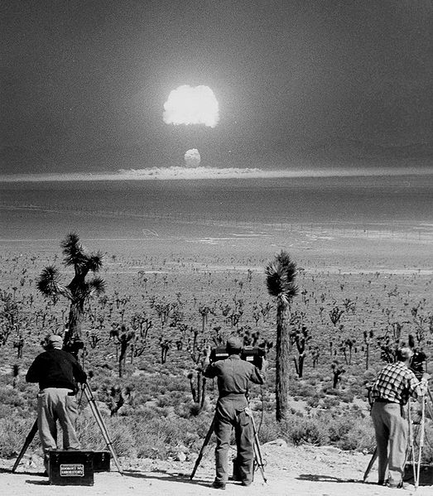
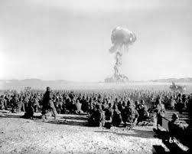

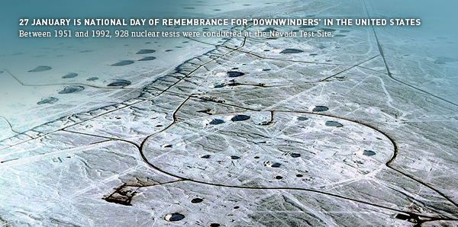
Craters formed from nuclear tests (above and below ground).

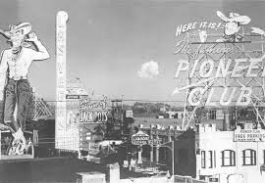

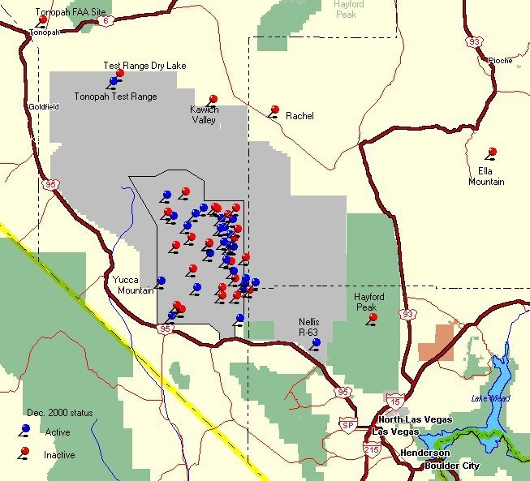
Geiger counter locations throughout Nevada.
