Name
Date

Quiz- Newton’s Laws of Motion
Part A- Multiple Choice
______ 1) First Law  ______ 2) Second Law  ______3) Newton  ______ 4) field force  ______ 5) contact force  ______ 6) inertia  ______ 7) equilibrium  ______ 8) force  ______ 9) Third Law | a) For every action there is an equal and opposite reaction.  b) objects that are either at rest or moving with constant velocity  c) physical contact between two objects  d) does not involve physical contact between two objects  e) An object at rest remains at rest, and an object in motion continue in motion with constant velocity unless the object experiences a net external force.  f) a push or a pull (or…an action exerted on an object which may change the object’s state of rest or motion”  g) the scientist contributed to the modern understanding of force and motion  h) the mass in an object affects it’s ________  i) The acceleration of an object is directly proportional to the net force acting on the object and inversely proportional to the object’s mass.

Part B- Identify/draw the forces (field and contact)
10) 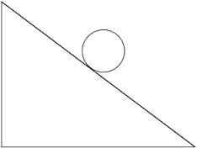 11) 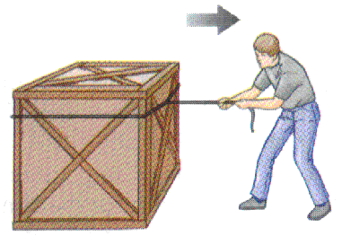

Part C- Calculating X and Y components
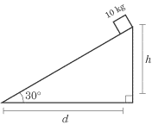Pretend the box is held at rest on a frictionless ramp by rope. What are the x and y components of the force of gravity? (Remember that F=m x a(aka-g))
12) x-component | 13) y-component

