Warm up for 10/06-10/10

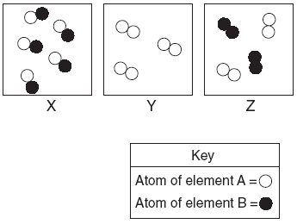
___________________________________________________________________________________________

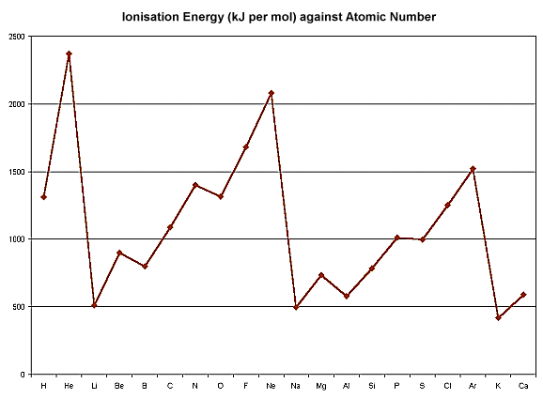

Warm Up questions

Monday- Which picture shows a element?

Tuesday- Which picture shows a compound?

Wednesday- At what atomic number (and chemical symbol), does the ionization energy reach 2350 kJ?

Thursday- Predict what atomic #21 would read- higher or lower than atomic # 20?

Friday- In between what two atomic numbers (and chemical symbols) is the greatest decrease in ionization energy?

