Name
Date
Period
Review for Test Unit 2 – Matter

- Define matter: _______________________________________________________________________
- What is the difference between mass and weight?

- What are the two main types of properties used to describe matter?

- Label the following as physical or chemical properties
  - Color _________________ c. Density __________________
  - Burning _______________ d. Reacts with acid _____________

- True or False: a change in state from a liquid to a gas is a chemical change.
- True or False: The Law of Conservation of Matter states that matter can be destroyed and created in chemical processes.
- Label the following as physical or chemical change
  - Milk sours _______________ c. Ice Melting _________________
  - Tire inflated with air ________________ d. Sugar dissolving in water ______________

- What are the three states of matter? _______________ __________________ _______________
- Draw a simple picture of each state of matter below and label it:

- Put the right state of matter next to the following:
  - Cannot change shape of volume and does not flow ______________
  - Cannot change volume but can change shape and does flow ____________
  - Can change shape, volume and does flow _______________
- Adding energy to a solid will change it to what state of matter?________________
- What is name given to the process when a gas changes to a liquid? ______________________
- What physical property did you use to separate the iron from the salt and sand in the Lab? _____________
- What did you do to get the sand out of the water? ________________________________
- What process could you use to get the dry salt out of the water? ___________________
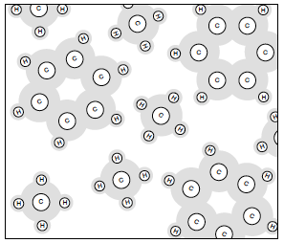
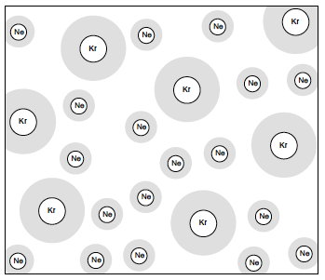
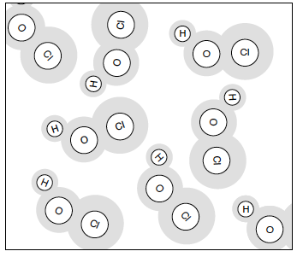
- Look at the pictures below and label each one as either an element, compound, mixture. Some pictures may need more than one label.

______________________ ________________________ ________________________

