Name
Date
Period

Ions through Bohr diagrams

K (potassium)
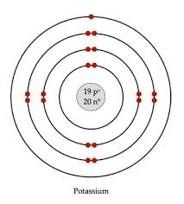
_________How many valence electrons (in the last energy level) does K have?
_________What group # is K in?
_________K needs to GIVE away its valence electrons because it is in Group 1, 2, or 13. If it gives away its valence electron (s), how many electrons does it have left? (atomic #/# of protons - # of valence electron (s) given away).
_________ If K has more protons then electrons what charge ( + or - ) would it have?
_________ Try to rewrite the chemical symbol with the charge and the # of electrons given away.

N (nitrogen)
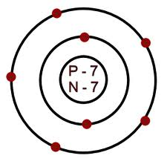
_________How many valence electrons (in the last energy level) does N have?
_________What group # is N in?
_________N needs to TAKE valence electrons because it is in Group 15, 16, or 17. If it TAKES valence electron (s), how many would it need to fulfill/meet the OCTET RULE?
_________ If N has more electrons then protons what charge ( + or - ) would it have?
_________ Try to rewrite the chemical symbol with the charge and the # of electrons TAKEN.

Additional Practice with Ions and their charges

*Remember that ALL atoms start out neutral meaning equal # of protons and equal # of TOTAL electrons.
Example K (potassium) is atomic # 19. This means it has 19 positive protons and 19 negative electrons. If K is in Group 1 that means it has 1 valence electron. If is the element is from Group 1, 2, or 13 it wants to GIVE away its negative energy. So now K would only have 18 electrons, but still 19 protons- making it positive. K⁺¹ because it has 1 more proton than electron.

If N needs (takes) 3 electrons, then it is written N⁻³.
**The anions are different because you want to get to 8 valence electrons. If N already has 5 valence electrons, then it needs to take 3 more to make 8.
Look at your # of valence electrons- if it is from groups 1, 2, or 13 then it wants to LOSE/GIVE away its electrons.

Put a check mark in the cation OR
The anion box (not both)
Element | Group # | # of valence electrons | Groups 1,2,13= cation (lose) | **Groups 15, 16, 17= anion (take) | Lose= +  Take= - | Rewrite symbol
K | 1 | 1 | x |  | +1 | K⁺¹
N | 15 | 5 |  | X | -3 | N⁻³
O
Ca
Br
S
Cl
Mg
Be

