Name
Date
Period

Remediating/Going over Unit 1 test
Answer the questions to the side-
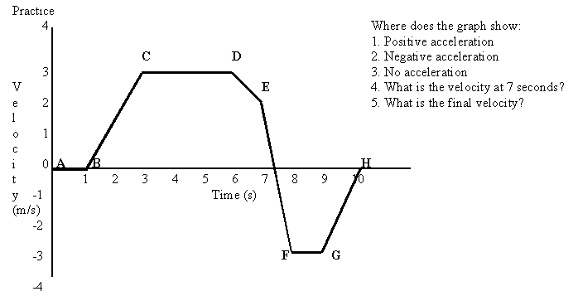

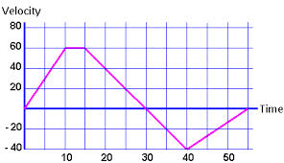
Explain the above graph- All FOUR answers need three parts a piece: While explaining this graph you need to write down the initial velocity and final velocity of that line/section. You need to state if the acceleration was increasing, none, or decreasing (aka- negative acceleration/deceleration). AND you must also include if the object is moving in the positive direction (right/top) or the negative direction (left/bottom).
6
7
8
9
10

11 A car increases its velocity from 0 m/s to 14 m/s in 2 s. What is the car’s acceleration?

12 A rocket car travels 500 m while being accelerated with a constant acceleration from rest at a rate of 5.0 m/s². What final velocity does it attain?

13 An apple falls from a tree and hits the ground 1 second later. With what speed does the apple hit the ground? How high was the apple above the ground when it dropped?

14 A girl jumps up 0.83 m to grab her brother’s toy off of a top shelf. What is the girl’s takeoff velocity and how much time did the jump take?

