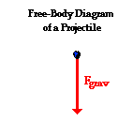
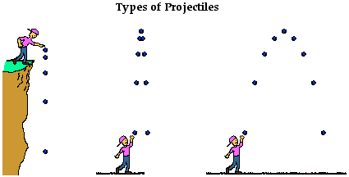

By definition, a projectile has a single force that acts upon it - the force of gravity. If there were any other force acting upon an object, then that object would not be a projectile. Thus, the free-body diagram of a projectile would show a single force acting downwards and labeled force of gravity (or simply F_{grav}).

A force is not required to keep an object in motion. A force is only required to maintain an acceleration. And in the case of a projectile that is moving upward, there is a downward force and a downward acceleration. That is, the object is moving upward and slowing down
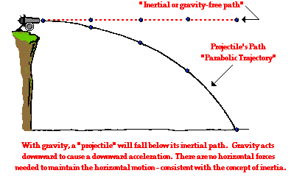

So far in Lesson 2 you have learned the following conceptual notions about projectiles.
- A projectile is any object upon which the only force is gravity,
- Projectiles travel with a parabolic trajectory due to the influence of gravity,
- There are no horizontal forces acting upon projectiles and thus no horizontal acceleration,
- The horizontal velocity of a projectile is constant (a never changing in value),
- There is a vertical acceleration caused by gravity; its value is 9.8 m/s/s, down,
- The vertical velocity of a projectile changes by 9.8 m/s each second,
- The horizontal motion of a projectile is independent of its vertical motion.

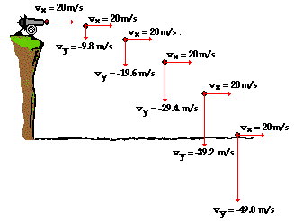

This is indeed consistent with the fact that there is a vertical force acting upon a projectile but no horizontal force.

But what if the projectile is launched upward at an angle to the horizontal? How would the horizontal and vertical velocity values change with time? How would the numerical values differ from the previously shown diagram for a horizontally launched projectile? The diagram below reveals the answers to these questions. The diagram depicts an object launched upward with a velocity of 75.7 m/s at an angle of 15 degrees above the horizontal. For such an initial velocity, the object would initially be moving 19.6 m/s, upward and 73.1 m/s, rightward. These values are x- and y-components of the initial velocity and will be discussed in more detail in the next part of this lesson.

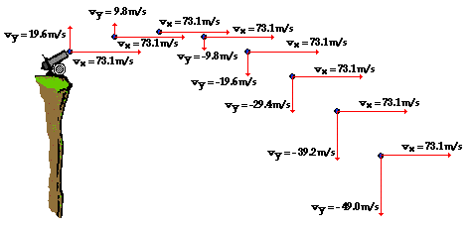

For non-horizontally launched projectiles, the direction of the velocity vector is sometimes considered + on the way up and - on the way down; yet the magnitude of the vertical velocity (i.e., vertical speed) is the same an equal interval of time on either side of its peak. At the peak itself, the vertical velocity is 0 m/s; the velocity vector is entirely horizontal at this point in the trajectory.

The horizontal displacement of a projectile is only influenced by the speed at which it moves horizontally (v_{ix}) and the amount of time (t) that it has been moving horizontally. Thus, if the horizontal displacement (x) of a projectile were represented by an equation, then that equation would be written as

x = v_{ix} • t

In the presence of gravity, it will fall a distance of 0.5 • g • t². Combining these two influences upon the vertical displacement yields the following equation.
y = v_{iy} • t + 0.5 • g • t²
(equation for vertical displacement for an angled-launched projectile)
where v_{iy} is the initial vertical velocity in m/s, t is the time in seconds, and g = -9.8 m/s/s (an approximate value of the acceleration of gravity). If a projectile is launched with an initial vertical velocity of 19.6 m/s and an initial horizontal velocity of 33.9 m/s, then the x- and y- displacements of the projectile can be calculated using the equations above

Use your understanding of projectiles to answer the following questions. Then click the button to view the answers.
1. Anna Litical drops a ball from rest from the top of 78.4-meter high cliff. How much time will it take for the ball to reach the ground and at what height will the ball be after each second of motion?

See Answer

It will take 4 seconds to fall 78.4 meters
Use the equation y = 0.5 • g • t² and substitute -9.8 m/s/s for g. The vertical displacement must then be subtracted from the initial height of 78. 4 m.
At t = 1 s, y = 4.9 m (down) so height is 73.5 m (78.4 m - 4.9 m )
At t = 2 s, y = 19.6 m (down) so height is 58.8 m (78.4 m - 19.6 m )
At t = 3 s, y = 44.1 m (down) so height is 34.3 m (78.4 m - 45 m)
At t = 4 s, y = 78.4 m (down) so height is 0 m (78.4 m - 78.4 m)

2. A cannonball is launched horizontally from the top of an 78.4-meter high cliff. How much time will it take for the ball to reach the ground and at what height will the ball be after each second of travel?

It will still take 4 seconds to fall 78.4 meters
Use the equation y = 0.5 • g • t² and substitute -9.8 m/s/s for g. The vertical displacement must then be subtracted from the initial height of 78. 4 m.
At t = 1 s, y = 4.9 m (down) so height is 73.5 m (78.4 m - 4.9 m )
At t = 2 s, y = 19.6 m (down) so height is 58.8 m (78.4 m - 19.6 m )
At t = 3 s, y = 44.1 m (down) so height is 34.3 m (78.4 m - 45 m)
At t = 4 s, y = 78.4 m (down) so height is 0 m (78.4 m - 78.4 m)
NOTE: the cannon ball's horizontal speed does not affect the time to fall a vertical distance of 78.4 m

One of the powers of physics is its ability to use physics principles to make predictions about the final outcome of a moving object. Such predictions are made through the application of physical principles and mathematical formulas to a given set of initial conditions. In the case of projectiles, a student of physics can use information about the initial velocity and position of a projectile to predict such things as how much time the projectile is in the air and how far the projectile will go. The physical principles that must be applied are those discussed previously in Lesson 2. The mathematical formulas that are used are commonly referred to as kinematic equations. Combining the two allows one to make predictions concerning the motion of a projectile. In a typical physics class, the predictive ability of the principles and formulas are most often demonstrated in word story problems known as projectile problems.
There are two basic types of projectile problems that we will discuss in this course. While the general principles are the same for each type of problem, the approach will vary due to the fact the problems differ in terms of their initial conditions. The two types of problems are:

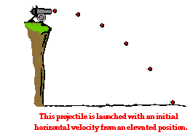
Problem Type 1:
A projectile is launched with an initial horizontal velocity from an elevated position and follows a parabolic path to the ground. Predictable unknowns include the initial speed of the projectile, the initial height of the projectile, the time of flight, and the horizontal distance of the projectile.

Examples of this type of problem are
- A pool ball leaves a 0.60-meter high table with an initial horizontal velocity of 2.4 m/s. Predict the time required for the pool ball to fall to the ground and the horizontal distance between the table's edge and the ball's landing location.

The solution of this problem begins by equating the known or given values with the symbols of the kinematic equations - x, y, v_{ix}, v_{iy}, a_{x}, a_{y}, and t. Because horizontal and vertical information is used separately, it is a wise idea to organized the given information in two columns - one column for horizontal information and one column for vertical information. In this case, the following information is either given or implied in the problem statement:

Horizontal Information | Vertical Information
x = ???  v_{ix} = 2.4 m/s  a_{x} = 0 m/s/s | y = -0.60 m  v_{iy} = 0 m/s  a_{y} = -9.8 m/s/s
As indicated in the table, the unknown quantity is the horizontal displacement (and the time of flight) of the pool ball. The solution of the problem now requires the selection of an appropriate strategy for using the kinematic equations and the known information to solve for the unknown quantities. It will almost always be the case that such a strategy demands that one of the vertical equations be used to determine the time of flight of the projectile and then one of the horizontal equations be used to find the other unknown quantities (or vice versa - first use the horizontal and then the vertical equation). An organized listing of known quantities (as in the table above) provides cues for the selection of the strategy. For example, the table above reveals that there are three quantities known about the vertical motion of the pool ball. Since each equation has four variables in it, knowledge of three of the variables allows one to calculate a fourth variable. Thus, it would be reasonable that a vertical equation is used with the vertical values to determine time and then the horizontal equations be used to determine the horizontal displacement (x). The first vertical equation (y = v_{iy}•t +0.5•a_{y}•t²) will allow for the determination of the time. Once the appropriate equation has been selected, the physics problem becomes transformed into an algebra problem. By substitution of known values, the equation takes the form of
-0.60 m = (0 m/s)•t + 0.5•(-9.8 m/s/s)•t²
Since the first term on the right side of the equation reduces to 0, the equation can be simplified to
-0.60 m = (-4.9 m/s/s)•t²
If both sides of the equation are divided by -5.0 m/s/s, the equation becomes
0.122 s² = t²
By taking the square root of both sides of the equation, the time of flight can then be determined.
t = 0.350 s (rounded from 0.3499 s)
Once the time has been determined, a horizontal equation can be used to determine the horizontal displacement of the pool ball. Recall from the given information, v_{ix} = 2.4 m/s and a_{x} = 0 m/s/s. The first horizontal equation (x = v_{ix}•t + 0.5•a_{x}•t²) can then be used to solve for "x." With the equation selected, the physics problem once more becomes transformed into an algebra problem. By substitution of known values, the equation takes the form of
x = (2.4 m/s)•(0.3499 s) + 0.5•(0 m/s/s)•(0.3499 s)²
Since the second term on the right side of the equation reduces to 0, the equation can then be simplified to
x = (2.4 m/s)•(0.3499 s)
Thus,
x = 0.84 m (rounded from 0.8398 m)
The answer to the stated problem is that the pool ball is in the air for 0.35 seconds and lands a horizontal distance of 0.84 m from the edge of the pool table.

The following procedure summarizes the above problem-solving approach.
- Carefully read the problem and list known and unknown information in terms of the symbols of the kinematic equations. For convenience sake, make a table with horizontal information on one side and vertical information on the other side.
- Identify the unknown quantity that the problem requests you to solve for.
- Select either a horizontal or vertical equation to solve for the time of flight of the projectile.
- With the time determined, use one of the other equations to solve for the unknown. (Usually, if a horizontal equation is used to solve for time, then a vertical equation can be used to solve for the final unknown quantity.)
One caution is in order. The sole reliance upon 4- and 5-step procedures to solve physics problems is always a dangerous approach. Physics problems are usually just that - problems! While problems can often be simplified by the use of short procedures as the one above, not all problems can be solved with the above procedure. While steps 1 and 2 above are critical to your success in solving horizontally launched projectile problems, there will always be a problem that doesn't fit the mold. Problem solving is not like cooking; it is not a mere matter of following a recipe. Rather, problem solving requires careful reading, a firm grasp of conceptual physics, critical thought and analysis, and lots of disciplined practice. Never divorce conceptual understanding and critical thinking from your approach to solving problems.

- A soccer ball is kicked horizontally off a 22.0-meter high hill and lands a distance of 35.0 meters from the edge of the hill. Determine the initial horizontal velocity of the soccer ball.

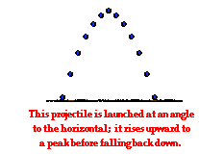
Problem Type 2:
A projectile is launched at an angle to the horizontal and rises upwards to a peak while moving horizontally. Upon reaching the peak, the projectile falls with a motion that is symmetrical to its path upwards to the peak. Predictable unknowns include the time of flight, the horizontal range, and the height of the projectile when it is at its peak.
Examples of this type of problem are
- A football is kicked with an initial velocity of 25 m/s at an angle of 45-degrees with the horizontal. Determine the time of flight, the horizontal distance, and the peak height of the football.
- A long jumper leaves the ground with an initial velocity of 12 m/s at an angle of 28-degrees above the horizontal. Determine the time of flight, the horizontal distance, and the peak height of the long-jumper.

The second problem type will be the subject of the next part of Lesson 2. In this part of Lesson 2, we will focus on the first type of problem - sometimes referred to as horizontally launched projectile problems. Three common kinematic equations that will be used for both type of problems include the following:
d = v_{i}•t + 0.5*a*t²
v_{f} = v_{i} + a•t
v_{f}² = v_{i}² + 2*a•d
where | d = displacement | a = acceleration | t = time
 | v_{f} = final velocity | v_{i} = initial velocity

Equations for the Horizontal Motion of a Projectile
The above equations work well for motion in one-dimension, but a projectile is usually moving in two dimensions - both horizontally and vertically. Since these two components of motion are independent of each other, two distinctly separate sets of equations are needed - one for the projectile's horizontal motion and one for its vertical motion. Thus, the three equations above are transformed into two sets of three equations. For the horizontal components of motion, the equations are
x = v_{ix}•t + 0.5*a_{x}*t²
v_{fx} = v_{ix} + a_{x}•t
v_{fx}² = v_{ix}² + 2*a_{x}•x

where | x = horiz. displacement | a_{x} = horiz. acceleration | t = time
 | v_{fx} = final horiz. velocity | v_{ix} = initial horiz. velocity

Of these three equations, the top equation is the most commonly used. An application of projectile concepts to each of these equations would also lead one to conclude that any term with a_{x} in it would cancel out of the equation since a_{x} = 0 m/s/s. Once this cancellation of ax terms is performed, the only equation of usefulness is:
x = v_{ix}•t

Equations for the Vertical Motion of a Projectile
For the vertical components of motion, the three equations are
y = v_{iy}•t + 0.5*ay*t²
v_{fy} = v_{iy} + ay•t
v_{fy}² = v_{iy}² + 2*ay•y

where | y = vert. displacement | ay = vert. acceleration | t = time
 | v_{fy} = final vert. velocity | v_{iy} = initial vert. velocity

In each of the above equations, the vertical acceleration of a projectile is known to be -9.8 m/s/s (the acceleration of gravity). Furthermore, for the special case of the first type of problem (horizontally launched projectile problems), v_{iy} = 0 m/s. Thus, any term with v_{iy} in it will cancel out of the equation.
The two sets of three equations above are the kinematic equations that will be used to solve projectile motion problems.

Solving Projectile Problems
To illustrate the usefulness of the above equations in making predictions about the motion of a projectile, consider the solution to the following problem.

Check Your Understanding
A soccer ball is kicked horizontally off a 22.0-meter high hill and lands a distance of 35.0 meters from the edge of the hill. Determine the initial horizontal velocity of the soccer ball.

Horizontal Info: | Vertical Info:
x = 35.0 m | y = -22.0 m
v_{ix} = ??? | v_{iy} = 0 m/s
a_{x} = 0 m/s/s | a_{y} = -9.8 m/s/s

Use y = v_{iy} • t + 0.5 • a_{y} • t² to solve for time; the time of flight is 2.12 seconds.
Now use x = v_{ix} • t + 0.5 • a_{x} • t² to solve for v_{ix}
Note that a_{x} is 0 m/s/s so the last term on the right side of the equation cancels. By substituting 35.0 m for x and 2.12 s for t, the v_{ix} can be found to be 16.5 m/s.

