Notes Unit 3 Matter #1

What is Chemistry?  What is Matter?  What is Mass?  What is Weight?  How do we identify matter?  What are the properties of matter?  What is a physical property of matter?  What is a physical change?  What is a chemical property?  What is a chemical change?  What is the Law of Conservation of Matter?  What is a chemical reaction?  Notes: Unit 3 Matter #2  What are states of matter?  What is a Solid?  What is a Liquid?  What is a Gas?  What is Plasma? | The study of ___________________________ and how it can change.  Anything that has ____________________ (takes up space). Everything on Earth!  Amount of _______________________ contained in an object. (count the atoms!)  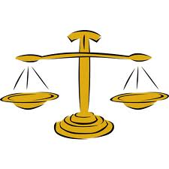  The mass of something times the force of __________. Less gravity – weigh less!  The moon has less gravity than Earth – go there and you weigh less.  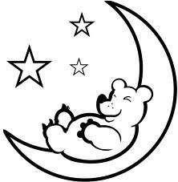  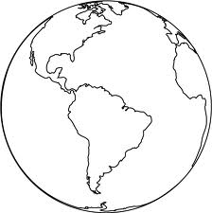  EARTH MOON  Mass 60 Kg (does not change) 60 Kg  Gravity Greater Less  Weight 132 pounds (does change!) 23 pounds  Matter has _____________________.  Properties are used to ______________ ________________.  Ex. The color, shape or size of something.  Two main categories:  _____________________ properties and  _____________________ properties  It can be observed _________________________ in the chemical make-up of the substance.  Examples:  ________ Density (mass/volume)  Hardness ___________(temperature it boils)  Odor Melting Point (temperature it melts)  Luster (Shine) Freezing Point (temperature it freezes)  ______________ Solubility(going into solution)  (solid, liquid, gas)  The substance can ____________________________________, but the chemical make-up and properties are the same  Example: when you freeze water (H₂O) it is still water (H₂O)  Examples:  - change in state: __________________________________  Still H₂O  - going into solution: _______________________________, still salt (NaCl)  - change in size – ____________________________________  A substance’s _____________________________________ into something else  Examples:  Being _________________________ (combustion - ability to catch on fire)  Able to ________________________________________ like acids or bases  The atoms of a substance rearrange to form a ____________________________  _______________________________________________  Example: Iron + Oxygen → Rust  Wood + Oxygen → Burning (combustion) → Carbon Dioxide + H₂O  Matter is ___________________________________________________ in any process  Another name for _________________________________________, showing the Law of Conservation of Mass – same number of atoms on both sides of arrow  Reactants → Products  4Fe + 3O₂ → 2Fe₂O₃  A physical property in which the substance changes its form __________________________________________________________________.  Common “states” or form of matter:  Solid Liquid  Gas Plasma  PROPERTIES BEHAVIOR OF PARTICLES DRAWING OF PARTICLES  Volume: Motion:  Shape: Distance:  Fluid? Energy:  PROPERTIES BEHAVIOR OF PARTICLES DRAWING OF PARTICLES  Volume: Motion:  Shape: Distance:  Fluid? Energy:  PROPERTIES BEHAVIOR OF PARTICLES DRAWING OF PARTICLES  Volume: Motion:  Shape: Distance:  Fluid? Energy:  PROPERTIES BEHAVIOR OF PARTICLES DRAWING OF PARTICLES  Volume: Motion:  Shape: Distance:  Fluid? Energy:  Like a Gas, but with positive and negative charges particles  Lightning is plasma!  Changes in States of Matter -  