Metric Measurements Review #3

Matching: write the letter of the definition next to the vocabulary word.

1. _____ | Mass | a. | Parts of the experiment that are kept the same  throughout an experiment
2. _____ | Weight | b. | The amount of space an object occupies
3. _____ | Volume | c. | Milliliter (mL), cubic centimeter (cm³)
4. _____ | L x W x H | d. | A prediction about the results of an experiment, also called an educated guess.
5. _____ | Density | e. | Is a measure of the force of gravity on mass (like you)
6. _____ | Hypothesis | f. | How much matter an object contains
7. _____ | Experiment | g. | Formula for the volume of a “regular” shaped object
8. _____ | Control | h. | Mass of an object divided by its volume
9. _____ | Independent  Variable | i. | A variable that is changed by the scientist  (What the scientist chooses to study)
10. ____ | Dependent  Variable | j. | A repeatable scientific procedure to test a hypothesis
11. ____ | Units of volume | k. | Expressed in numbers
12. ____ | Valid | l. | A statement reflecting the validity of a hypothesis
13. ____ | Data | m. | Observations/Measurements from an experiment
14. ____ | Quantitative | n. | A variable that the scientist measures as a result  of the independent variable
15. ____ | Conclusion | o. | Results that are consistent and accurate
16. ____ | Line Graph | p. | Used to show percentages
17. ____ | Bar graph | q. | Used to show a trend or a change over time
18. ____ | Pie Graph | r. | Used to show differences between similar things

Short Answers

19. a. Use your ruler to measure the height, length and width of the 315.26g piece of metal pictured here, and then calculate the volume and density. (show your work)
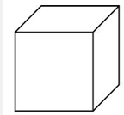

b. Using the density chart identify the metal. Density Chart
Gold 19.3g/cm³
Silver 10.5 g/cm³
20. a. Volume by Difference: Determine the volume of the objects in the graduated cylinders below

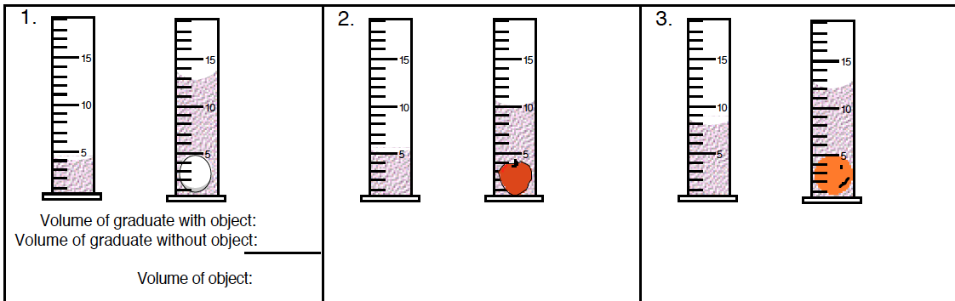

b. using the volume in picture A. above, if the egg has a mass of 10g, what is it’s density? SHOW WORK

21. A chemist measured the temperature of his chemical reaction over time.

What is the independent variable? ______________________________

What is the dependent variable? ________________________________

Graph the data from the data table below,
include a title and a scale that uses the
whole graph paper.

Time, min | Temperature,  0C
0 | 20
5 | 24
10 | 28
15 | 32
20 | 38

