Lab: Experimental Investigation of Alka-Seltzer
Using the Scientific Method
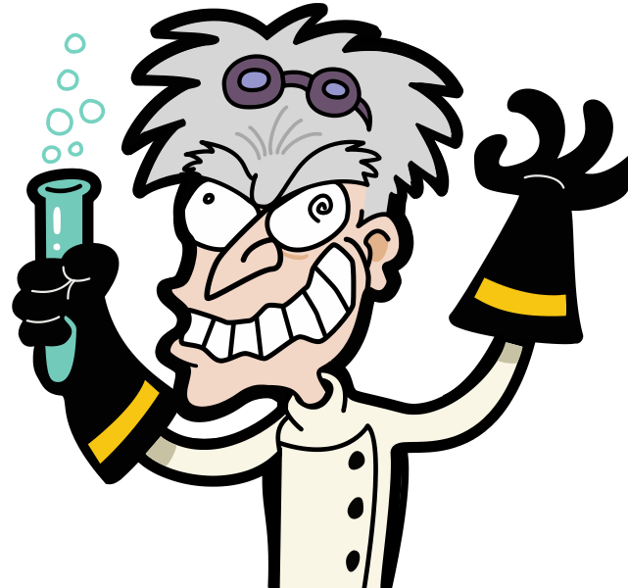
1. Question:

What type of water is best for making Alka-Seltzer dissolve faster?

Variable being tested: Type of Water
Room temperature water Warm water
Cold water Acid water

2. Hypothesis:
(What is your best guess?)
If I use _________________________________ type of water then the Alka-Seltzer will dissolve faster.

3. Experiment: Write a procedure then perform an experiment to test your hypothesis

- Independent variable (what are you changing?) __________________ of water

- Dependent variable (what will you measure?) ________________ for tablet to dissolve

  - How will you measure it? __________________________

- Control variables (what must stay the same?)

  - Whole tablet or half a tablet? _______________________

  - Amount of water in milliliters _______________________

  - Stirring or no stirring _______________________________
4. Data:
Independent: | Dependent: | Controlled
Type of Water | Time, minutes:  seconds | Whole or half  tablet | Amount of water | Stirring/No Stirring
Room Temp
Warm
Cold
Acid

5. Data Analysis:

Title: ____________________________________________________________________

Time,
Minutes: Seconds

Type of Water

6. Conclusion:

My hypothesis was that if I used _____________________ type of water then the Alka-

Seltzer would dissolve faster. Looking at the graph the data shows that it

dissolved fastest in the ______________ water. Therefore, my hypothesis was (correct or

incorrect) ____________________.

Review of Experimental Investigation of Alka-Seltzer:

- State the 6 steps in the Scientific Method (look at the numbered steps of this investigation)

1. __________________________________________________

2. __________________________________________________

3. __________________________________________________

4. __________________________________________________

5. __________________________________________________

6. __________________________________________________

- What question were you trying to answer?

- What was the independent variable in this investigation?

- a. What variable did you measure?

b. What do we call this variable?

- Why was it important to use the same amount of tablet (whole or half) each time?

- What other variables did you have to keep the same?

- What could you have done to make this lab more accurate?

