Calculating Speed problems

D.U.F.A.S.- a way to solve (5 steps that you MUST use for EVERY CALCULATION- in order to get credit)
Define (what you Units Formula Apply Solve
are looking for)

Sample Problem 1- (speed)
If you drive a distance of 400 mi in 8 hrs, what is your average speed?

Sample Problem 2- (time)
In an automobile collision, it was determined that a car travelled 150 ft before the brakes were applied. If the car had been travelling at the speed limit of 40 mi/hr (60 ft/s), what was the driver’s reaction time?

Sample Problem 3- (distance)
You are travelling at 35 mi/hr (about 50 ft/s) and your reaction time is 0.2 s. Calculate the distance you travelled during your reaction time.

Graphs associated with speed: (copy these to your notebook)
--------Notice that time (t) is on the x-axis and distance (d) is on the y-axis
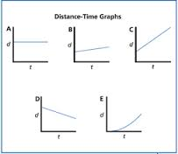
A) An object is at rest. As time increases there is no change in position.
B) An object is travelling at a slow speed. As time increases, there is a small change in position.
C) An object is travelling at a fast speed. As time increase, there is a greater change in position.
D) An object is travelling in the opposite direction. As time increases, the object is changing positions.
E) An object is increasing its speed every second. Notice that a changing speed is a curve on a distance-time graph.

You try: Describe each letter on the graph below.
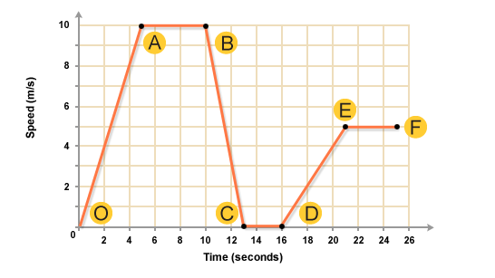
O to A-
A to B-
B to C-
C to D-
D to E-
E to F-

