m Warm ups 03/23rd- 27th

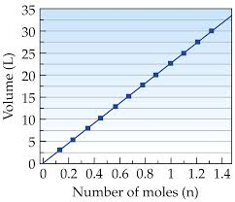

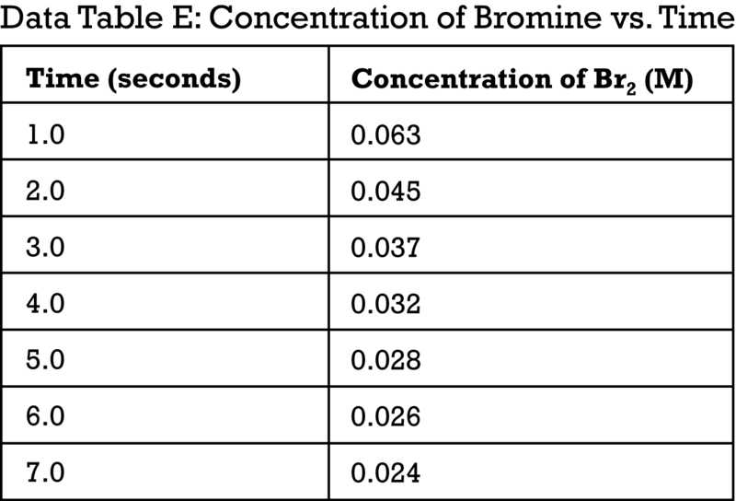

Good Morning 03/23/15

What type of graph is this (direct OR inverse)?

Page #s are as follows:
#50- warm up 03/23-03/27
#51- Notes- The Mole #1
#52- Molar Mass Practice Worksheet #1

Good Morning 03/24/15

(Use the top graph)- What scale is the independent axis?

Page #s-
#53 Basic Stoichiometry PhET lab

Good Morning 03/25/15

(Bottom table)- As time increases, what happens to the concentration of Br₂?

Thursday 03/26/15
Bell Ringer- (use the bottom table) What type of relationship does this graph have (direct or inverse)?

DO NOT DRAW THIS GRAPH
Here is what it would look like (blue line)- 