Warm ups 03/16-3/20

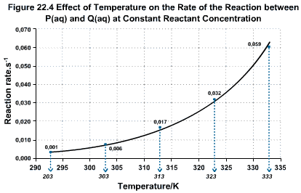

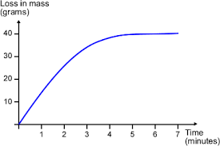

Good Morning! 03/16/15

What is the title of the dependent axis?

Tuesday 03/17/15

What scale does the independent axis use?

In 20 minutes, I’m checking in the review packet (again).

Happy Wednesday 03/18/15

(Use the top graph)- Is this graph a direct relationship or inverse?

DO NOT WRITE THE BELOW INFO.
(direct is when one variable increases, the other increases) (inverse is when one variable increases, the other decreases)

Good Morning 03/19/15

(Use the bottom graph)- At what time does the “loss in mass” taper out (straighten)?

Page #s:
#47 Video notes
#48 Converting Units with…

Happy Friday 03/20/15

(bottom graph) What are the units given for the dependent axis?

