Warm up 02/17-02/20

A homologous series of compounds are compounds where the elements of a family are each bounded to the same element. For example, family 4A in the periodic table consists of carbon, silicon, germanium, and tin. If each of these is bounded to hydrogen, it would produce a homologous series, , , , and . If we graph the boiling points of this homologous series, we would get the graph sketched on the left side in the figure below. However, if we graph the boiling points of the homologous series of family 6A combined with hydrogen, we get quite a different graph, as seen on the right side of the sketch.

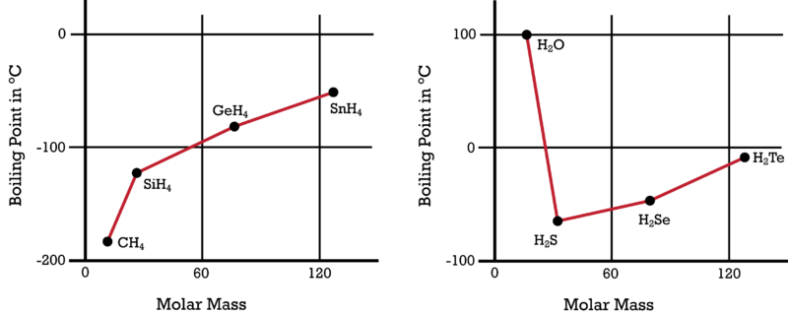

Good Afternoon! 02/17/15

(Number 21)Bell Ringer- Use the left graph, what is the boiling point for SnH₄?

Good Morning 02/18/15
What type of bond are ANY of the compounds on either graph?

(**Test will be Friday**)- you just picked up the review
Page Numbers:
24- “Notes- Ionic vs Covalent Bonding”
25- “Review: Naming Ionic and Covalent Compounds”
26- “Review for Test- Chemical Bonding”
Good Morning! 02/19/15

From the right graph, name the covalent compound for H₂O?
(DO NOT WRITE “WATER”- I will not stamp your paper. Use your reference sheet= prefixes)

H2 O
Dihydrogen monoxide

You have the next 15 minutes to finish your Review Sheet…then; I will walk around and check it in. Missed yesterday?-Grab one from the crate!

AT 12:54 pm I’ll be checking in your review

Happy Friday 02/20/15

At what temperature does dihydrogen monoxide boil? (Use the right graph)

For the test make sure you have a “periodic table” AND the “reference sheet/flow chart” extras are up front by the late sign-in sheet

