Warm up February 9th-13th

At high levels of exposure (now rare in the United States), lead can cause mental retardation, convulsions, and even death.
The CDC monitors blood lead levels (BLLs) of children and adults. Figure 10.2

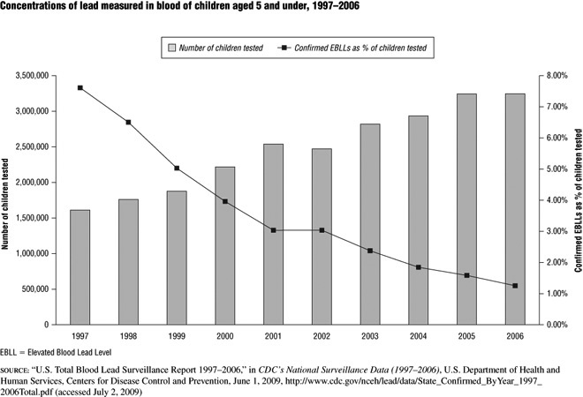

Good Morning!
Monday 02/09

During which two years was the same number of children tested for lead?

Answer- 2005 & 2006
Tuesday 02/10

Explain the “Confirmed EBLL’s as % of children tested” trend from 1997 to 2006.

Answer- the EBLL decreases from 1997 to 2006 (from 2001-2002 there really isn’t a change)

Wednesday 02/11
How old were the children tested?

Answer- 5 years old and under

Thursday 02/12

What does BLL standard for?

Answer- Blood lead levels

Friday 02/13

What % of Confirmed EBLL in Children was there in 2000?

Answer- 4%

