Guided Notes- Bonding #1
Electrons  Electron configuration  Chemical properties  Valence Electrons  How many valence electrons are there?  Octet Rule  Why do they have partial or full shells?  Lewis Dot Diagrams  Ionization energy  Cation  Anion | Electrons are the only ________ subatomic particles directly involved in chemical reactions.  Electron configuration = Distribution of electrons in an atom's electron _________ (orbitals).  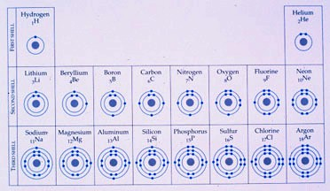  If an atom does not have enough __________ to fill all shells, the outer shell will be the only one partially filled.  Chemical properties of an atom depend upon the number of __________ ______________.  Example- Group 1 all the elements are highly reactive to H20.  Valence electrons = Electrons in the atom’s ______________ energy shell.  You can tell how many valence electrons there are in each atom by looking at its _______ ____________.  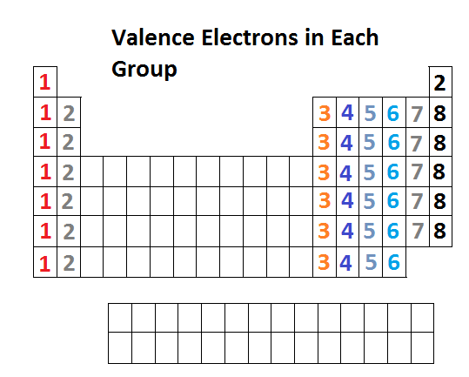  Group # # of valence electrons  1 1  2 2  13* 3  14* 4  15* 5  16* 6  17* 7  18* 2 (for period 1 ONLY) 8 (noble gases already have a full energy shell!)  *As you can see you “ignore” the 1 in Groups 13-18)  Practice- How many valence electrons does K have? (Hint- what group # is K in?) _______  Practice- How many valence electrons does C have? _______  An atom with a complete valence shell is ___________ or inert.  An atom with an ___________ valence shell is chemically reactive (tends to form chemical bonds until it has 8 electrons to fill the valence shell).  Octet rule = Rule that a valence shell is __________ when it contains 8 electrons (except H and He in Period 1).  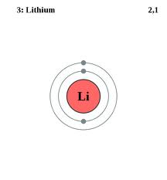 _partial_ valence shell 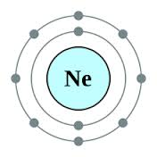_empty_ valence shell  Li has ____ valence electrons and Ne has _____ valence electrons.  *Remember you need 8 electrons for an atom to be ___________.  A Lewis structure is a structural representation of a molecule where dots are used to show _________ position around the _______.  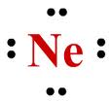  Ionization energy is a measure of the difficulty of ___________ electron or the strength by which an electron is bound.  The higher the ionization energy, the more ________ it is to remove an electron.  *Remember as you go from _left__ to _right_ across the periodic table it becomes more and more difficult to remove an electron.  A cation is an ion with a ________________charge and is formed when an atom ___________ one or more electrons.  Groups 1, 2, and 13 tend to be _________.  An anion is an ion with a _________________charge and is formed when an atom ___________ one or more electrons.  Groups 15, 16 and 17 tend to be _________.  Practice: Is Ca a cation or an anion? (Hint- what is Ca’s group #?)__________  Is F a cation or an anion? __________

