Name
Period
Date

Chemistry Station Review (1st semester)
These stations are similar to ones we have already done during the course of our Chemistry year. Your group should not need more than a few minutes at each. You have 14 stations to complete- time is of the essence!

Station1- Sugar Cube
1 Identify the color of the sugar cube. ____________________ Which type of property is this? _________________
2 Use the mortar and pestle to crush a small piece of the cube. Crushing is which type of change? _____________
3 Look at our results from Hey Sugar lab, is sugar reacting to acid a physical or chemical change? (circle answer)
4 If sugar’s formula is C₁₂H₂₂O₁₁ then would it be considered an element or a compound? (circle answer)
5 Look at sugar’s formula again, what type of elements are C, H, and O? __________________________________

Station 2- Cube
6 Look at the picture to calculate the mass of this cube. ______________
7 Now find the volume of the cube. ____cm x____cm x_____cm = _______cm³
8 Lastly, find the cube’s density. (Density= mass/ volume) ______________________________________________
9 What element would this cube represent if its atomic number is 29? _____________________________

Station 3- Rock, Sand, Salt, and Iron mixture
10 Is this mixture heterogeneous or homogeneous? (circle answer)
11 If you were asked to separate the salt from the mixture, what would be the best method? _________________

Station 4- Foil
12 Cut the foil one time with scissors. What type of change did you make happen? _________________________
13 Hook the wire clamps to the foil. Does it conduct electricity? ____________
14 What types of physical properties does it have? ____________, _______________, and _____________________
15 What type of element would you classify it as (based off your answers to the above question)? _______________
16 If its atomic mass is number 26.98, what element is it? __________________
Station 5- Salt water
17 NaCl (salt) is what type of pure substance? (Reference the flow chart) _____________________________
18 When you mix H₂0 with NaCl what type of mixture is it? ___________________ How do you know? Can you see the different particles or does it all look the same? _________________________
19 If you wanted to get the salt out of the water, what could you do? _____________________________________
20 Pretend you took the temperature after mixing, read the temperature picture on the wall. _____________

Station 6- Radiation
21 What is the name of this instrument? ____________________________________________________________
22 What is this instrument used for? ________________________________________________________________
23 There are two pictures stuck to the Station 6 sign. Draw the correct picture under each word.
Fusion Fission

24 From the picture on the wall. Match the letter to the vocabulary word.
_______ alpha
_______ beta
_______ gamma

Station 7- Nails
25 Test the “new” nail with the wire probes. What happens? ________________________________________
26 Test the “rusty” nail with the wire probes. What happens? _______________________________________
27 A nail rusting is what type of change? ________________________________________________________
28 Does the nail lose properties when a chemical change happens? ___________________________________
29 If I told you it had 26 protons, you would tell me its identity is _______________________.

Station 8- Models of the Atom
30 Use the cards to match the scientist to the correct model of the atom. Put the correct letter next to the scientist’s name.
1 Democritus _______  2 Dalton ______  3 Atomic Theory ______  4 Thomson _______ | 5 Rutherford _______  6 Bohr _____  7 Schrodinger _____

Station 9- Rock
31 Does it have luster? _____________
32 If this rock is brittle, doesn’t conduct electricity, but does have luster, what type of element is it? _____________
33 Use the triple beam balance to calculate the “rock’s” mass. __________________________________________
34 Add at least 20 mL of water to the graduated cylinder. Record your initial amount- it doesn’t have to be 20 mL, then add the rock. How much volume does just the rock have? _________________________
35 What is the rock’s density? ________________
****Please DUMP the water and remove the rock from the graduated cylinder. Thank you!****

Station 10- Bohr diagrams of Lithium atom
36 Left picture: Charge of particle  # of protons-  # of neutrons-  Atomic mass-  # of electrons- | 37 Right picture: Charge of particle  # of protons-  # of neutrons-  Atomic mass-  # of electrons-
38 What is DIFFERENT between the two diagrams? _______________________________
39 Write the isotope form for BOTH diagrams ____________________ and _______________________

Station 11- Half-Life
40 Look at the four test tubes in the rack. Mentally relate these test tubes to a half-life graph. The second test tube has about how much water in it compared to the first? _________________
41 Calculate the half-life of Uranium-238 (used in nuclear power plants). Uranium has a half-life of about 4 billion years. Pretend you start with 20 gram sample. How much is left after 12 billion years?
 | Start | 1st half-life | 2nd half-life | 3rd half-life | 4th half-life
Quantity
Time | 0
Station 12- Heartburn Help
Fill your beaker to about 50 ml. Break the antacid tablet. Use no more than a half. Smaller piece = faster results! Drop the antacid tablet into the water.
42 What type of reaction happens? __________________ How do you know? _____________________________
43 Pretend a thermometer took the new liquid’s temperature, what does it read (on the picture?) _____________
44 When the tablet is completely dissolved, what type of mixture is it? _________________________________
**Please dump the water down the drain when your group is finished**

Station 13- Ingredients of a pencil
45 Properties of this element include: it is dull, brittle, and doesn’t react with acid. What type of element is it? _______________
46 This pencil has an element with 6 total electrons. What is the element’s identity? _____________________

Station 14-States of Matter
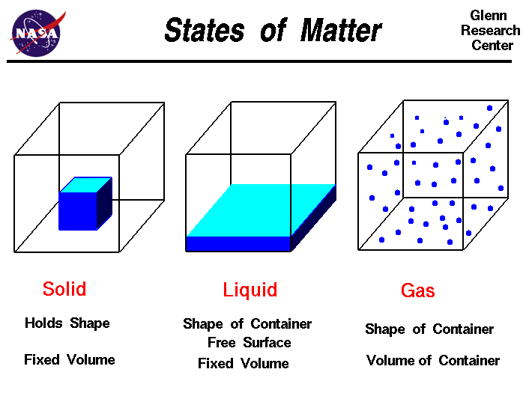
47 Under each box put the object’s name that matches the particle movement.

Station 15- “New” Unknown Element
Physical properties: brittle, dull, doesn’t conduct electricity
Chemical properties: doesn’t react with acid, doesn’t burn
48 What type of element is this? _________________________
49 Where would your find this element (section #) on the periodic table? I II or III (circle your answer)

