Computer Login
Name- 0351-Student
Password- 351Rancho

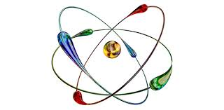 Nuclear Chemistry – Research Topics
- Food Preservation Using Radiation:
- History of the Nevada Nuclear Test Site and Current Events:
- Nuclear Power Plants in the US and the World:
- Las Vegas’s Yucca Mountain and Current Events:
- History of Radiology and Current Events:
- Nuclear Warfare & Weapons of Mass Destruction (WMDs):
- Nuclear Medicine Diagnostics and Treatments:
- Fission vs Fusion:
- Radiation Therapy:
- Radiocarbon Dating and How It’s Used to Date Fossils:
- Storage of Nuclear Waste: (New Mexico)
- Radon hazards (Local or entire U.S.)

Presentation Options:
- Poster paper
- PowerPoint presentation (10 slides) or Prezi
- Five page paper with references

