Warm up- 01/05-01/09
The danger of heavy metals is that collectively, they accumulate in your body over time and have been linked to long-term health issues such as cancer, reproductive and developmental disorders, neurological problems (memory loss, mood swings) nerve, joint and muscle disorders, cardiovascular, skeletal, blood, immune, kidney, skin, and hormonal problems… and the list goes on. Essentially, every and any aspect of your body could be adversely affected. Where it relates to make-up, the heavy metals can be absorbed through your skin, and in the case of lip products, even ingested. The report, “Heavy Metal Hazard”, outlines the results of tests of 49 facial makeup items, from 35 different brands, that were selected from across a spectrum of categories and brands.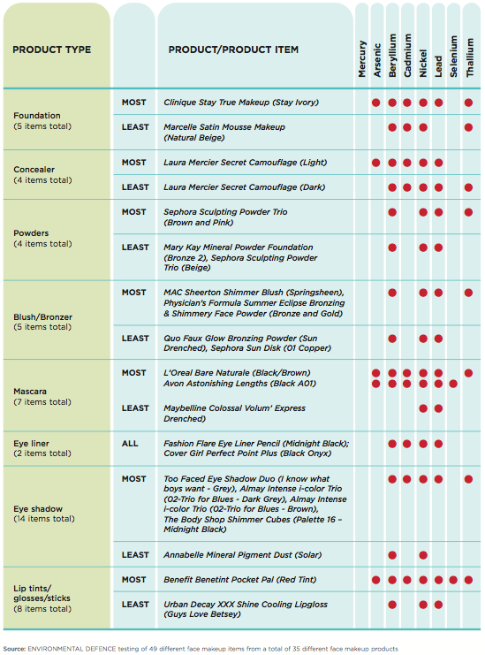

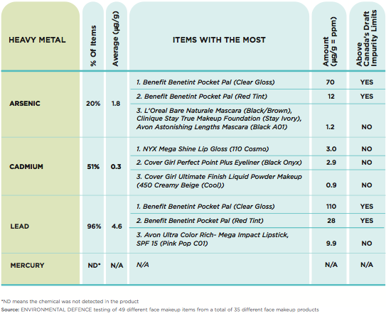

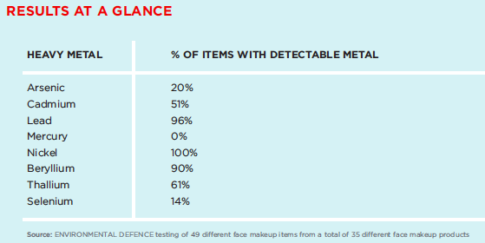

Good Morning 01/09/15

Bell Ringer- Which product type had the most items tested?
**Any old work is due today**

Side notes-
-you will have ~5 minutes to finish up any review stations
-In 6 minutes, I will check-in the Station Review AND the 1st four page review (Tuesday’s)

Good Morning 01/08/15

Bell Ringer- Why would companies use metal in their products? (hint- think about the properties of metals)

**Friday is the LAST day to TURN in ANY OLD work!!

Good Afternoon 01/07/15

Bell Ringer- Which metal is present in ALL of the listed make-up products?

**Friday is the LAST day to TURN in any OLD work!!

Good Morning 01/06/15

Bell Ringer- How many different makeup brands were tested?

Welcome Back & Happy New Year!! 01/05/15

Bell Ringer- What is the bell ringer analyzing? (read the paragraph)

