Name
Date
Period

Work and Power Worksheet #1

1) How much work is done when a 5 N force moves a block 4 m?

2) Fred applies a 350 N force to move his stalled car 40 m, how much work did Fred do?

3) How far will 350 J raise a block weighing 7 N?

4) How far will 350 J raise a 7 kg mass?

5) How much power does it take to do 500 J of work in 10 s?

6) How much work can be done by a 300 W motor in 60 s?

Pretend that the ball has a mass of 20 kg.
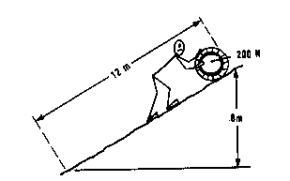

7) If it takes 200 N to slide the ball up the ramp, how much work will it take to slide the box up the ramp?

8) Instead of sliding, how much work will it take to lift the ball to the top of the ramp?

9) Which way takes more work? If you could only use 100 N which way would you use?

