What are the main categories of elements?  What are the physical properties of Metals?  What are the properties of Nonmetals?  Why is hydrogen with the metals?  What are the properties of Metalloids?  Check for Understanding  Identifying the groups/families on the table activity | Elements can be grouped into 3 large categories based on their properties: metals, metalloids and non-metals.  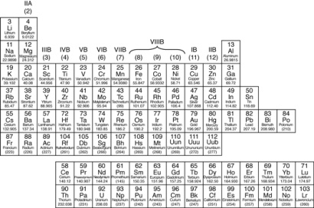  Metals - _____________________ side of the Periodic Table  Largest Category of Elements  Physical Properties:  - Luster - ________________________________________  - Ductile - ________________________________________  - Malleable - _____________________________________  - Conductors - ____________________________________  - State of Matter at room temperature – ________  except _________________, a ___________________  Nonmetals - _____________ side of the Periodic Table  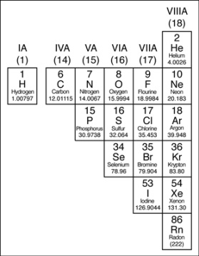  Second Largest Category of Elements  _______________ ______________________  have the properties of ______________________!  - Luster -__________________________  - Ductile - _________________________  - Malleable - _______________________  - Conductors - ______________________  - State of Matter at room temperature – Some are ____________________________ some___________________________ one _____________________, ____________________  Examples - ________________________ _______________________  Hydrogen is a _______ and therefore a nonmetal but it is put in Column 1 because of its electron structure.  Metalloids (Semimetals) – on the ____________________  *Smallest category – 7 elements  Have properties of _________________ and ____________________  All _______________  Some are _______________________________  Important in the semiconductor and computer chip industry  How would you categorize a material that has no luster and does not conduct electricity? ______________  How would you categorize a material that can be made into wire and does conduct heat? _____________  Why is it best not to use cooking pans with a metal handle?  _______________________________________________  You will be color coding your periodic table according to the following:  Group (Column #) Family Name Color  1 Alkali Metals dark blue  **Very reactive –  draw a bomb over column  2 Alkaline-earth Metals light blue  3 -12 Transition Metals light green  13 Boron Family yellow  14 Carbon Family light brown  15 Nitrogen Family dark brown  16 Oxygen Family orange  17 Halogen Family light red  18 Noble Gases dark red or purple  **Royal Family-  Draw a crown over the column

