Warm Up- November 17th-21st
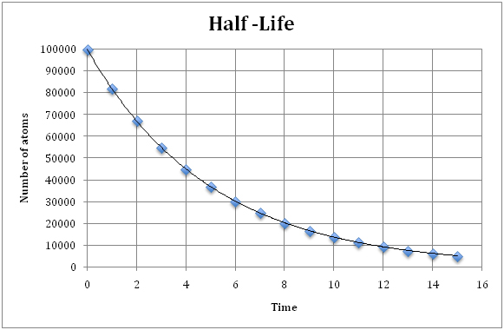

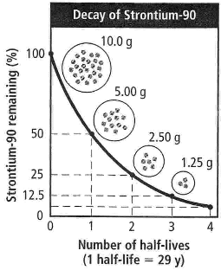

Monday- How many # of atoms exist after 9 half-lives (time)?
Tuesday- What is the dependent variable? (top graph)
Wednesday- Explain the top graph.
Thursday- How much of Strontium-90 is left after 3 half-lives?
Friday- What percent is 5.0 g of Strontium?

