Name
Date

Review for Newton’s Law Unit (part 2)
1 Which law tells us that forces exist in pairs?
2 Which law states that acceleration of an object is directly proportional to the net force acting on the object?
3 Which law applies to why the state of Nevada makes you wear a seatbelt?
4 Explain equilibrium.

5 Draw or give an example of an object in equilibrium.

6 How do we measure inertia?
7 Draw a free-body/force diagram of a helicopter lifting off a landing pad.

8 Which type of friction doesn’t allow the object to move?
9 Which type of friction tells us that the object is moving?
10 Would my mass or weight be different on the moon vs Earth? Why?

11 Your mom hangs a Christmas wreath on your front door using string to hold it up- it is in equilibrium. The wreath has a mass of 25 kg.
a) Draw a free body/force diagram of the wreath.

b) Write a net force equation for all of the forces acting in the y-direction.

c) What is the force of tension in the string?

12 You buy a wheelbarrow at Home Depot and load it up with rock from your backyard. The wheelbarrow with rock inside of it has a mass of 75 kg. You are applying a force of 125 N at an angle of 35 degrees above the horizontal. The coefficient of kinetic friction between the wheelbarrow and ground is .32.
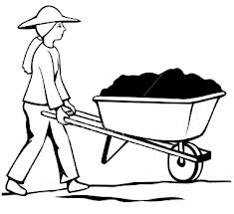 (No gender discrimination here!) 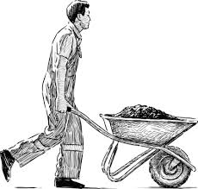
a) Draw the free-body/force diagram for the wheelbarrow as it is pushed along the ground.

b) Calculate the magnitude of the normal force. (use the net force in the y-direction)

c) Calculate the magnitude of the frictional force between the wheelbarrow and the ground.

d) Calculate the acceleration of the wheelbarrow. (use the net force in the x-direction)

13 Identify an opposing force. (Example- A person hits a wall (walks into it). The wall hits the person back.)
a) A tennis racquet hits a ball. ___________________________________________________
b) The floor exerts a force on the spoon dropped. ____________________________________
c) The car exerts a force on the concrete wall. _______________________________________

