Part 2- The Physics of Motion- video questions
Bungee Jumping
Either draw a person bungee jumping or write down all of the forces during a bungee jump.

Who originated (not the modern) bungee jumping?

Bicycling
What changes the speed of a bicyclist (or anything?)

Label the forces involved while riding a bike
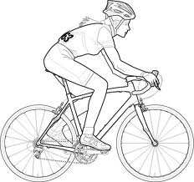

What is making the flag on the bike move?

Skydiving
When forces are balanced this means that the skydiver stops ______________________.

______ ______________ has to be greater than gravity to slow the skydiver down.

Flight
What is the name of the counter force that keeps the plane from falling out of the sky? _____________
Does the air on top of the wing travel faster or slower than the air on the bottom of the wing? (Circle faster or slower)
Does the air on the top travel a further or shorter distance than the air on the bottom of the wing? (Circle further or shorter)

