Name
Date
Period

Part A- Instructions- Identify each of the atoms below by proton or electron count. Write the name of the elements in the box.
1  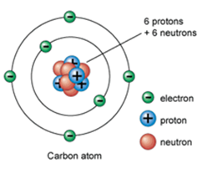 | 2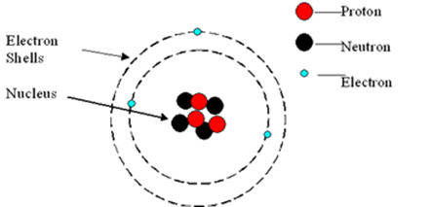 | 3  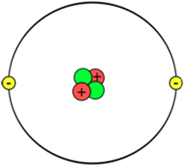
4  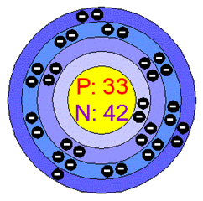 | 5  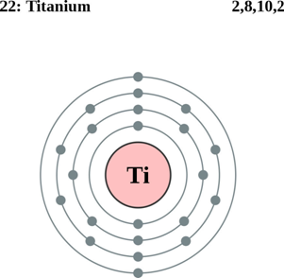 | 6  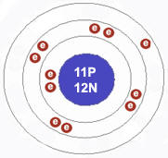
7  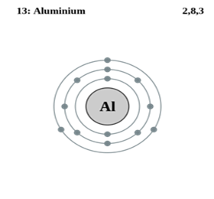 | 8  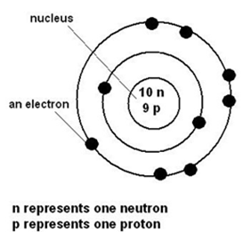 | 9  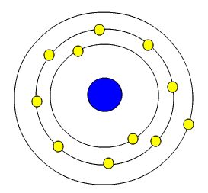

Part B- Short answer
10) What two particles does the nucleus contain?
11) Where is most of the mass of an atom?
12) What do we do with the average atomic mass on the periodic table?
13) What tells us the chemical identity of an atom? (aka- what never changes)
14) If I tell you Barium’s mass number is 139, but the periodic table reads 137.33- what is different?
Part C- What was each scientist’s major discovery (or discoveries):
15) Democritus-
16) Dalton-
17) Thomson-
18) Rutherford-
19) Bohr-
20) Schrodinger-

Part D- Chronologically organize the pictures below. Write number 1 that corresponds to the first model of the atom and so on.
21)
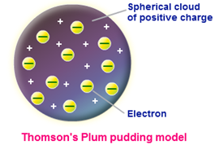 | 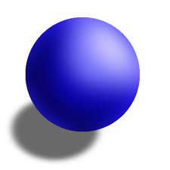 | 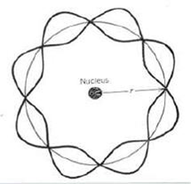
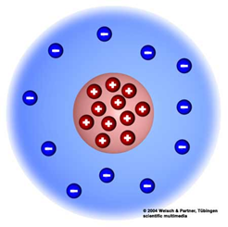 | 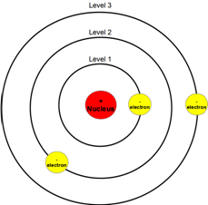

Part E- Make your own examples:
22) isotope (isotope symbol form)
23) isotope (nuclear symbol form)

