Warm Up Graph/Diagram for September 22-26th
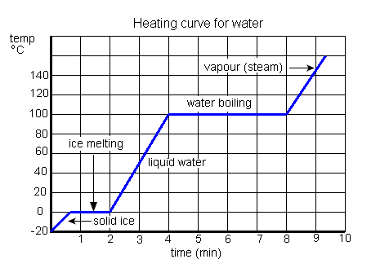

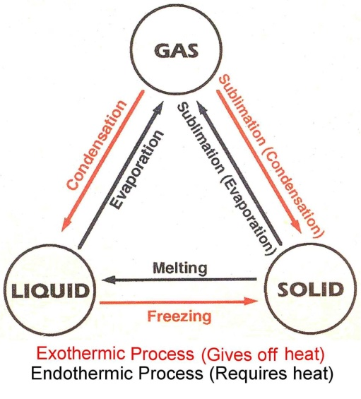

Monday- At what temperature does ice begin melting?

Tuesday- What is it called when a solid changes into a liquid?

Wednesday- How much time does it take from the ice melting until the water begins to boils?

Thursday- A lake freezes during the winter- Is this an exothermic or endothermic process?

Friday- (Compare the graph & diagram) What is another word for steam?

