Metric Measurement Review

Matching: draw a line from the word to its definition.

mass the amount of space an object takes up
pipet used to measure mass
volume a unit of length/distance
graduated cylinder the amount of matter in an object
triple beam balance used to make drops of liquid
thermometer unit of temperature
meter used to measure volume of liquids
liter glassware used to mix chemicals
⁰C used to measure temperature
beaker a unit of volume

Reading Scientific Equipment

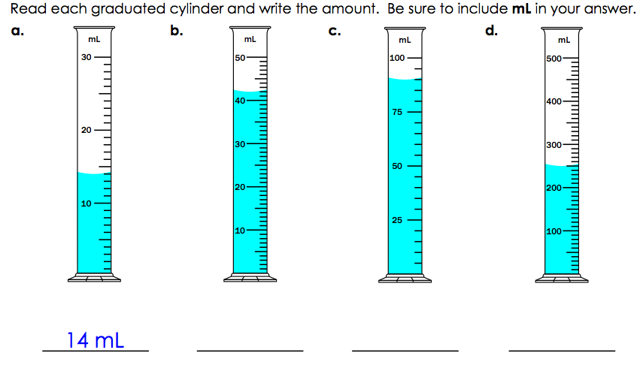

Volume by Difference: Determine the volume of the objects in the graduated cylinders below:

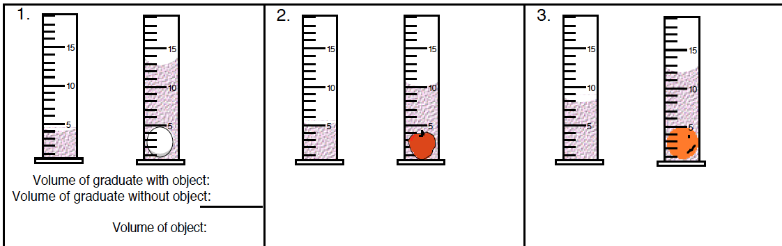

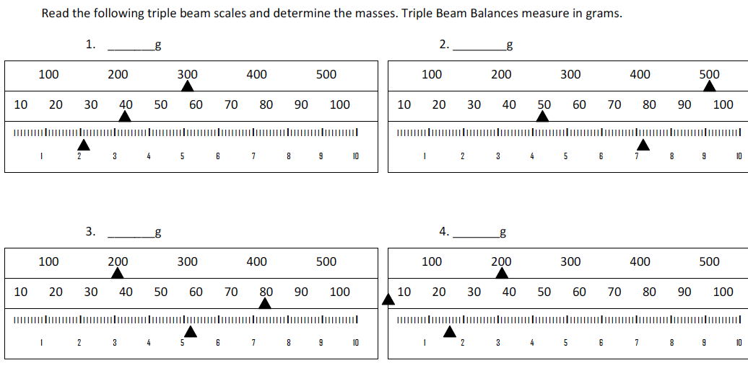

Determine the length of the rods above the metric rulers. Write your answer next to the rod and don’t forget to add cm.
