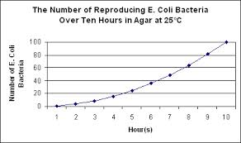

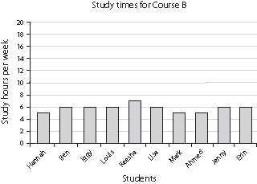

Uses for hydrogen chloride and hydrochloric acid
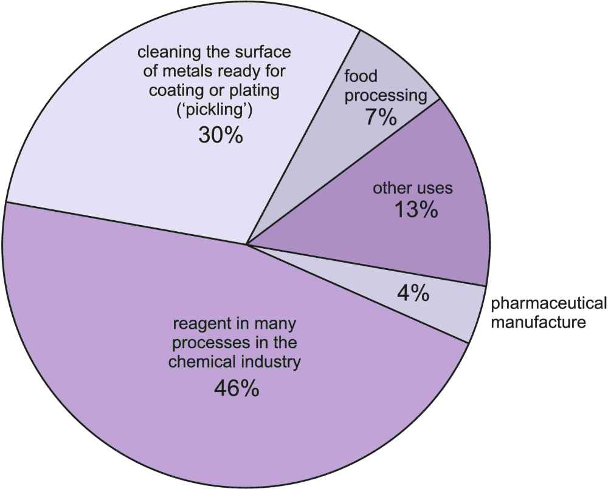

Bell ringer questions 09/15-09/19
Monday
What type of graph is “The Number of Reproducing…”? (a line graph, bar graph or pie chart)

Tuesday
Looking at the bar graph, what could we change to use the whole graph?
Or How could this bar graph be improved?
Side note- (Yes, the graph is probably used to demonstrate how little students study, but we want the kids to use the whole page or graph paper for their work when they make their own.)

Wednesday
Using the pie chart- what total percentage should all of the “Uses for hydrogen chloride and hydrochloric acid” add up to?

Thursday (each of you pick which question fits your students’ ability)
Looking at “The Number of Reproducing…” what can you conclude?
(or What does the slope tell us?)
(or Do you see in increase or decrease in reproduction of E. Coli as time increases?)

Friday
How could you turn “Study times for Course B” into a pie chart?

