Bell Ringer for 09/08-09/12

Mass versus Volume of Differenct Metals

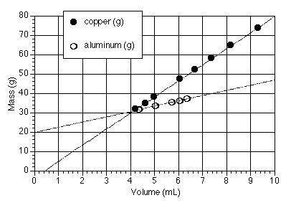
metal | density (g/mL)
aluminum | 2.702
carbon (graphite) | 2.25
copper | 8.92
iron | 7.86
magnesium | 1.74
silicon | 2.33

Monday
Identify the name of each axis.

Tuesday
Identify the scale of each axis.

Wednesday
Which metal has the lowest density and which has the highest density?

Thursday
At 6 mL, what is the mass of EACH metal?

Friday
Which metal has the greatest density and which element has the lowest density?

