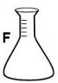 | Flask | Glassware used to mix and store liquids
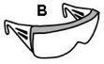 | Goggles | For eye protection
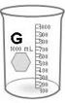 | Beaker | Used for mixing chemicals
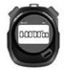 | Stopwatch | Used for timing
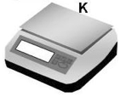 | Electronic Balance | Measures the mass (like weight). Has a digital readout.
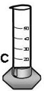 | Graduated Cylinder | Measures the volume of a liquid
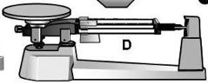 | 3-Beam (Triple Beam) Balance | Measures the mass (like weight)
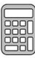 | Calculator | Used for math calculations
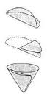  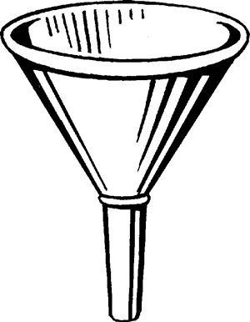 | Funnel  Funnel Paper | Used to separate a solid from a liquid.  Folded paper used to catch the solid.
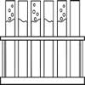 | Test Tube  Test Tube Rack | Used to hold small quantities of substances.  Rack that holds test tubes.
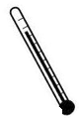 | Thermometer | Used to measure temperature
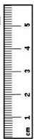 | Metric Ruler | Used to measure length in centimeters and millimeters.
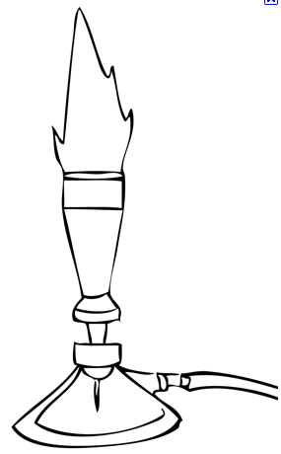 | Bunsen Burner | Makes a flame used to heat chemicals
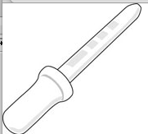 | Medicine Dropper (pipette) | Used for small volumes of liquid
 | Microscope  Microscope Slides | Used to see very small things  Used to put specimens on to view under a microscope.

