Warm ups 04/12-4/16

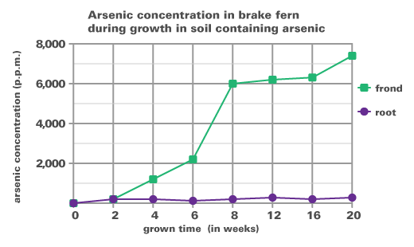

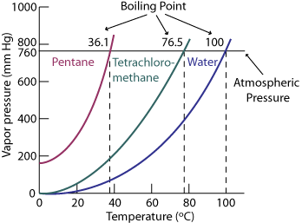

Good Morning 04/13/15

(top graph) Does the frond or the root receive more arsenic overall?

Agenda:
Binder check 45-61
(64) “10-2 Apply”
(65) warm up
(66) “11-2 Practice Problems’

