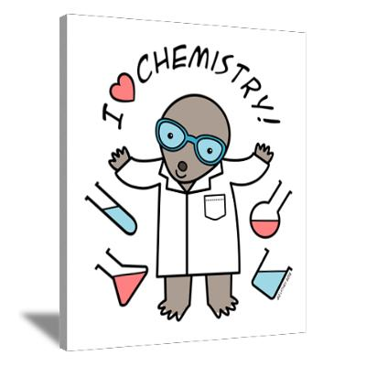
Review – The Mole #1

- Molar Mass Calculations
  - What is the molar mass of NaHCO₃?

  - How many grams are 54 moles of NaHCO₃?

  - How many moles are 234 grams of NaHCO₃?

- Questions from your Notes – The Mole #1

  - Complete: 1 Mole = _______________________________________________ of anything

  - According to Avogadro’s Law what would 1 liter of H₂ gas have in common with 1 liter of O₂ gas?

  - What is Avogadro’s Number? ____________________________________

  - What is Molar Mass?

- Dimensional Analysis - Converting Units

  - Convert 4,800 days to years

  - Convert 40cm to m
day yr

- Questions from your Notes – Chemical Reactions: Rates of Reactions
  - What is the Collision Theory?

  - What 2 things need to happen for an “Effective Collision?”

  - Explain in terms of the Collision Theory why increasing the temperature speeds up a chemical reaction.

- Balancing Equations – balance the following equations

  - _____ NO₂ → _____ O₂ + _____ N₂

  - _____ Ag(NO₃) + _____ Cu → _____ Cu(NO₃)₂ + _____Ag

- Naming – Name the following

  - N₂O₅ _____________________________________________________

  - Cu(OH)₂ _________________________________________________

  - CaF₂ _____________________________________________________

- Vocabulary – match the words with their definitions

1. ____ | Dimensional Analysis | a. | 6.022 x 10²³
2. ____ | Average Atomic Mass | b. | A unit used to count atoms by mass in grams. It is based on the quantity of atoms in12 grams of Carbon-12.
3. ____ | Atomic Mass Unit (amu) | c. | A way to convert between units using equivalent measures as fractions.
4. ____ | Mole | d. | The average atomic mass expressed in grams. This is equal to the mass of one mole of atoms or compounds.
5. ____ | Avogadro’s Law | e. | Equal volumes of different gases, at the same temperature and pressure, contain an equal number of particles.
6. ____ | Avogadro’s Number | f. | Unit used to express the mass of one atom relative to Carbon-12.
7. ____ | Molar Mass | g. | Average of the masses of the isotopes of an element as found in nature. This is the number listed on the periodic table.

