Lab: Making Crystal Ornaments

Purpose: To observe the crystal formation of an ionic compound.

Background: In this lab a homogeneous solution of the ionic compound sodium borate and water will be made. By dissolving an excess of sodium borate in hot water and letting it cool, the ionic compound will drop out of solution and form crystals. Crystal shape is the result of a repeating, orderly arrangement of the ions as they drop out of solution. This arrangement is called the crystal lattice. The repeated pattern is known as the unit cell. In this lab the positive sodium and negative borate ions are arranged into a crystal lattice that has a unit cell known as a simple monoclinic.

Repeating Pattern of Positive Unit Cells or Shapes of Crystals
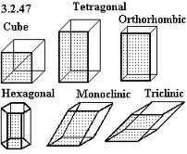
and Negative Ions
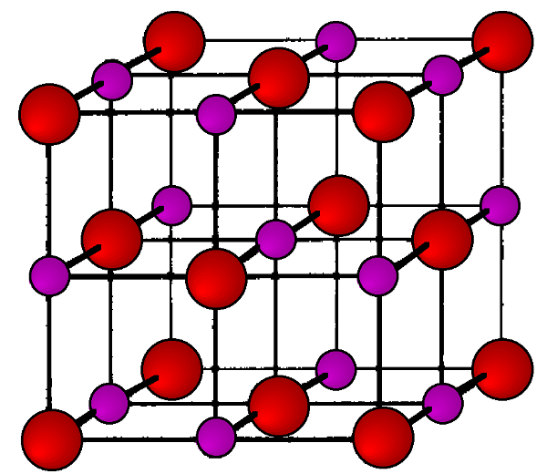

Procedure

- Bend a chenille wire into a desired ornament shape.
- Cut a string 9” long and tie to top or ornament.
- Lower the ornament into the 250-ml beaker and make sure it will fit without touching sides.
- Tie other end of string to stick to suspend it into the beaker without touching the bottom.
- Mass 33 g of Sodium Borate (Borax)
- Add 200 ml of hot water to the 200ml mark on the beaker
- Add the Sodium Borate
- Stir until mostly dissolved
- Put beaker on the hotplate and let solution heat just until clear (about 2 min.)
- Carefully lower ornament into beaker
- Label paper with period and group member name
- Place Beaker on the paper and leave to cool overnight
- Next day remove from solution and allow to dry on a towel
- Look at the crystals under a microscope and compare to sodium chloride crystals.

