Feb 23rd- 27th

Counting atoms
 | 1st element atom count | 2nd element atom count | Name of bond
Be₃N₂
CF₄
K₂O
NCl₃
MgS

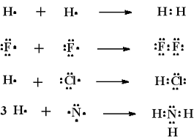

Good Morning! 02/23

Complete the graph on the front with how many atoms each compound has.

*If you weren’t here Friday, you need to make up the test!

 | 1st element atom count | 2nd element atom count
Be₃N₂ | Be- 3 | N-2
CF₄ | C- 1 | F- 4
K₂O | K- 2 | O- 1
NCl₃ | N- 1 | Cl- 3
MgS | Mg- 1 | S- 1

Good Morning! 02/24

Complete the graph by filling in the correct names for EACH compound (use your “Reference Sheet”.

Name of Bond
Be₃N₂ Beryllium DiNitride
CF₄ Carbon Tetrafluoride
K₂O Potassium Oxide
NCl₃ Nitrogen Trichloride
MgS Magnesium Sulfide

Good Morning! 02/25

Write the chemical formulas for ALL of the lewis dot diagrams.

Good Morning! 02/26

Use the top table- identify EACH of the bonds as ionic or covalent.

Good Morning! 02/27

USE YOUR FLOW CHART- try to name each of the Hydrogen bonds (from the lewis dot section).

