Warm up February 2nd- 6th

In electric vehicles, LiFePO4 batteries offer greater range, power and safety. They provide full power until they are completely discharged, and recharge in just 2.5 hours. LiFePO4 chemistry is also environmentally friendly — it’s the least toxic of all the battery types.
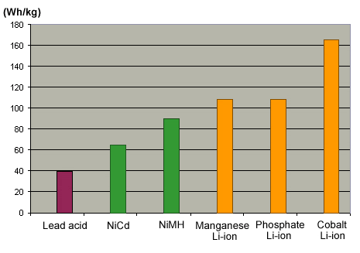

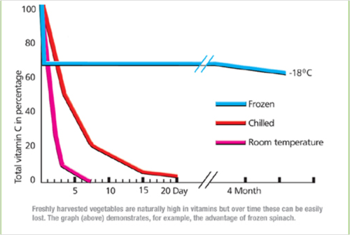

Monday 02/02

Which battery has the most Wh/kg (one watt-hour per kilogram)?

Answer- Cobalt Li-ion

Tuesday 02/03

What is the bottom graph portraying?

Answer- spinach in different situations (frozen, chilled, room temp.)

Wednesday 02/04

During what day number do all of the environments for the spinach have the same quantity of Vitamin C?

Answer- day 1

Thursday 02/05

Provide a title for the bar graph on top.

Possible answer- Average watt-hour per kilogram for different battery types.
or
Power Supplied by Various Battery types

