Notes – Properties of Ionic Compounds

What is the structure of an ionic compound?  What is a crystal lattice?  What is the unit cell?  What are the different types of unit cells?  Example – NaCl  Other properties:  Are ionic compounds brittle or malleable?  Melting Point  Soluble in Water  Conduct Electricity | Ionic compounds form crystalline solids of repeating patterns of positive ions (cations) and negative ions (anions.)  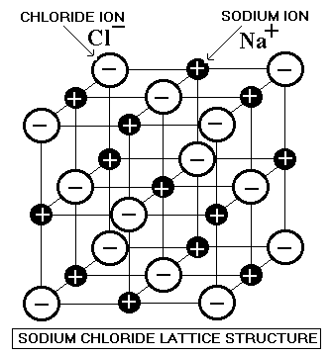  Crystal lattice is the repeating pattern of cations to anions that forms the solid.  The smallest part of the crystal lattice that shows the repeating pattern is called the unit cell. The crystal grows unit cell by unit cell.  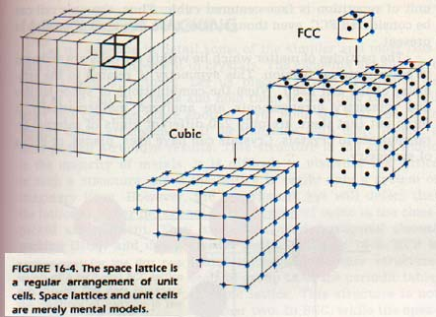  There are 7 basic types of unit cells in crystals:  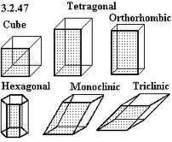  Sodium Chloride (table salt) is a cube crystal  Sodium Borate (Borax) is a Monoclinic crystal  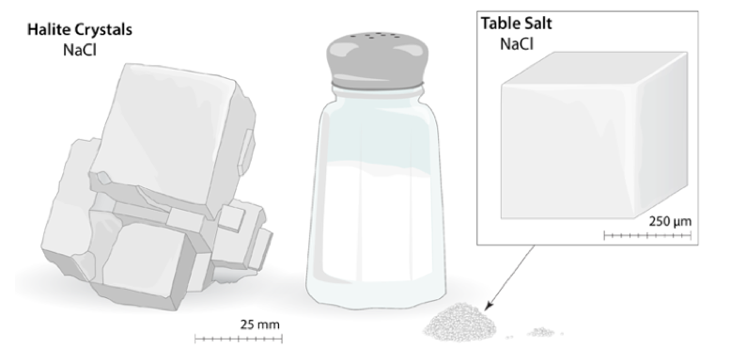  Ionic compounds are brittle. They break (or shatter) along the lines of the ionic bonds.  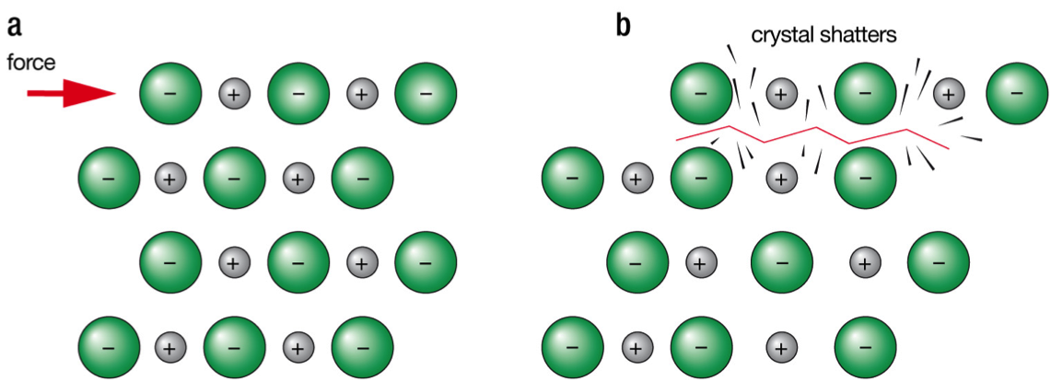  Ionic compounds have high melting points (high temperature is needed to make an ionic compound become a liquid)  Example: Sodium Chloride melts at 1,474°F (801°C).  This indicates the electrostatic bonds ( + - ) are very strong.  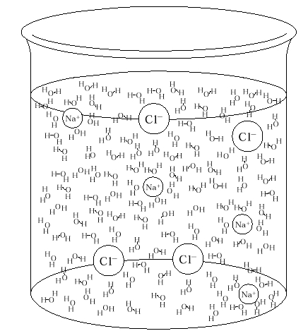  Many ionic compounds are soluble (dissolve ) in water. The solid breaks into free ions that move between the water molecules.  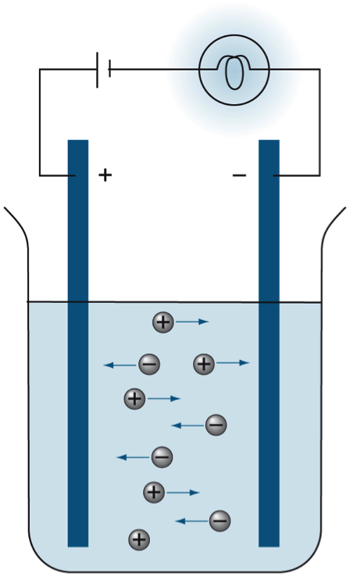  Crystalline solids - No  Molten (liquid) – Yes  Dissolved in water – Yes

