Guided notes- Bonding #2
Chemical Bonds  Ionic Bonds  Example  Practice  Review- Guided Notes #1 & 2 | These attractions between atoms ____________ molecules together.  We will be learning about ionic and covalent bonds, but there are more.  Ionic bonds are formed by the electrostatic attraction after the complete _____________ of an electron from a cation to an anion.  The __________ atom attracts the electrons because it is much more electronegative than the cation atom.  Example- An ionic compound salt (e.g. NaCl or table salt).  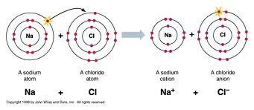  *The Na atom (a cation) ___________ the Cl atom (an anion) it’s one valence electron.  **The right picture shows how BOTH the Na atom and the Cl now have ___________ valence shells. Both are now _____________ and complete.  Practice: Mg would like to “give away” its two valence electrons. What group would be a good suggestion? _____________  Br would like to have a full valence shell. Who could Br “take an electron” from? _____  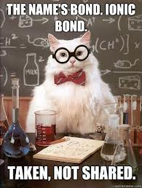 **Remember “I”onic bond. It gives and takes, but  does NOT share.  Review:  Electrons charge- Octet rule/goal- Cation- (group #s) Anion- (group #s)  Valence electrons- (location)- Always stable group- Types of elements (cations)- Types of elements (anions)-

Name
Period
Date
Lewis Dot Diagrams (Ionic Bonding)

Instructions: Draw the Electron Dot Diagrams for the following elements.
Cations: (use one color or x’s) | Anions: (use another color or o’s) | Ionic Bonds: (use your two different colors or your x’s and o’s when bonding) Make a FULL valence shell.
1 Li | F | LiF
2 Mg | S | MgS
3 Al | N | AlN
4 Na | Cl | NaCl
Instructions: Answer the following multiple choice and fill-in-the-blank questions using your guided notes (if needed).
5 When an atom has a full valence shell it is ______________ (stable or unstable) atom.
6 How many electrons does a “full” valence shell have?
7 Which group always has a full valence shell?
8 Group numbers ____, ____, and ____ are usually cations.
9 Cations _________ (give or receive) electrons.
10 Groups numbers ____, ____, and _____ are usually anions.
11 Anions _________ (give or receive) electrons.
12 Which of the following atoms is more likely to LOSE one or more electron? K, F, B, or Ne
13Which of the following atoms is more likely to GAIN one or more electrons? K, F, B, or Ne
14 Which of the following atoms is a stable atom? K, F, B, or Ne
15 If electrons are being lost and gained, explain what happens to the charge of the once neutral atom.

