Name

Date

Period

Circular Motion/ Centripetal Acceleration Practice

1. A 900-kg car moving at 10 m/s takes a turn around a circle with a radius of 25.0 m. Determine the centripetal acceleration and the net force acting upon the car.

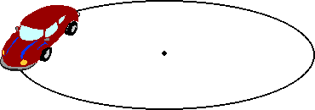

Find acceleration (using your NEW formula)

|  |  |  |  |
| --- | --- | --- | --- |
| Units | Formula | Algebra | Solve |

Net Force (Hint- think about Newton)

|  |  |  |  |
| --- | --- | --- | --- |
| Units | Formula  F= ma | Algebra | Solve |

2. There is 7650 N of friction acting upon a 900-kg car. The car is making a 180-degree turn around a curve with a radius of 35.0 min 11 s. Determine the maximum speed with which the car can make the turn. 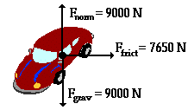

|  |  |  |  |
| --- | --- | --- | --- |
| Units | Formula  http://www.physicsclassroom.com/Class/circles/u6l1e1.gif | Algebra | Solve |

These three questions build on each other and all require the answer to be correct in the prior problem to get the next correct answer.

3. A yo-yo with a string 0.8 m long is swung vertically in a circle at a person’s side. If the yo-yo takes 0.9 seconds to make one complete circle:

What is the yo-yo’s velocity? (use your NEW velocity formula)

|  |  |  |  |
| --- | --- | --- | --- |
| Units | Formula  http://www.physicsclassroom.com/Class/circles/u6l1e1.gif | Algebra | Solve |

What is its acceleration? (use your NEW centripetal acceleration formula)

|  |  |  |  |
| --- | --- | --- | --- |
| Units | Formula | Algebra | Solve |

What is the centripetal force acting on the yo-yo? (mass of the toy is 0.3 kg) (Use the NEW centripetal force formula)

|  |  |  |  |
| --- | --- | --- | --- |
| Units | Formula  http://hyperphysics.phy-astr.gsu.edu/hbase/imgmec/cfmag.gif | Algebra | Solve |