9.2 (p. 256-260)
Formulas that connect to momentum:
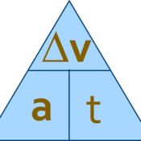 a_{avg}= v = v_{f}-v_{i}
t t
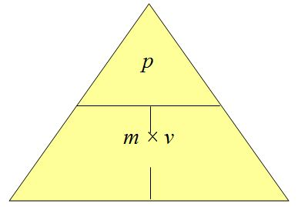 p= m(v)
Momentum (p)

Impulse momentum theorem
J= p_{f}-p_{i}= p
(Impulse = change in momentum)

Graphs:
Momentum is directly proportional to mass
Momentum is directly proportional to velocity
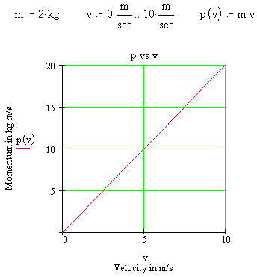

*If the duration of the collision (aka- time) can be increased, the force of the impact will be decreased.

9.3 (p.260-262) (not much to write down in 9.3)

Definitions:
Impulse approximation- (ignoring) the small forces

