Warm up Jan 20th-23rd
RDA is the recommended daily allowance provided by
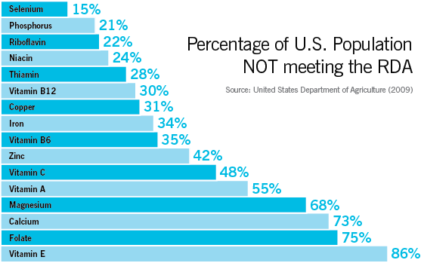

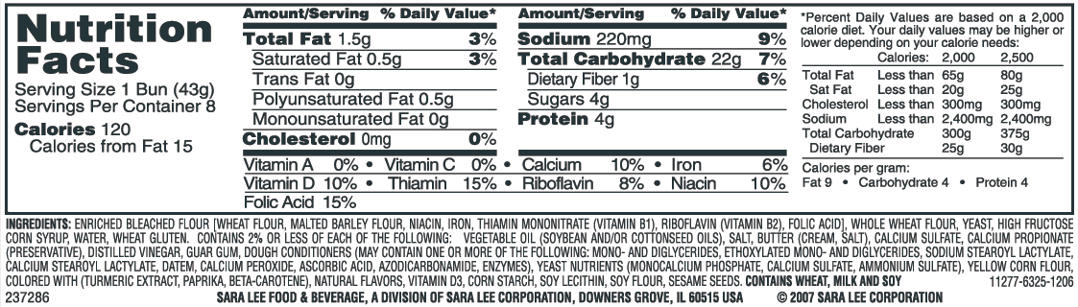

Good Morning 01/21/15
Wednesday- From yesterday’s answer- identify each of your seven answers as a metal or nonmetal?

(answer- metals: magnesium, zinc, iron, copper AND the nonmetals- calcium, phosphorus, selenium)

Good Morning 01/22/15

Thursday- What “elements” are found in a 1 serving size bun? (hint- look at the %)

(answer- calcium and iron)

Happy Friday! 01/23/15

Friday- If you ate two buns how much sodium would you be getting?

(answer- 440 mg or 18%)

Thank you!

Good Morning 01/20/15

Which “elements” is the U.S. Population not getting enough of? (hint- you may need your periodic table to reference)

